
INDUSTRY REPORT
Utilities in the US
Feb 2026

About

IBISWorld
IBISWorld specializes in industry research with coverage on thousands of global industries. Our comprehensive data and in-depth analysis help businesses of all types gain quick and actionable insights on industries around the world. Busy professionals can spend less time researching and preparing for meetings, and more time focused on making strategic business decisions.

Table Of Contents | Standard

1. About 4
Codes 4
Definition 4
Related Terms 4
What's Included 4
Companies 4
Related Industries 5
Additional Resources 5
2. At a Glance 6
Key Takeaways 6
Products and Services 7
Major Players 8
Key External Drivers 9
Industry Structure 9
SWOT 10
Executive Summary 10
3. Performance 11
Highlights 11
Key Takeaways 11
Performance Snapshot 12
Outlook 20
Life Cycle 22
4. Products and Markets 23
Key Takeaways 23
Products and Services 23
Major Markets 27
International Trade 29
5. Geographic Breakdown 30
Key Takeaways 30
Business Locations 31
6. Competitive Forces 36
Key Takeaways 36
Concentration 36
Barriers to Entry 37
Substitutes 38
Buyer & Supplier Power 40
7. Companies 42
Key Takeaways 42
Market Share 43
Companies 44
8. External Environment 54
Key Takeaways 54
External Drivers 54
Regulation & Policy 58
Assistance 59
9. Financial Benchmarks 60
Key Takeaways 60
Cost Structure 60
Key Ratios 63
10. Key Statistics 65
Industry Data 65

1. About
https://my.ibisworld.com/us/en/industry/22/about

Codes
NAICS 2017 - USA | 22
NAICS 2022 - USA | 22

Definition
The sector comprises operators engaged in the provision of various utility services, such as electric power, natural gas, steam supply, water supply and sewage removal. Excluded from this sector are operators primarily engaged in waste management services classified in Subsector 562, Waste Management and Remediation Services. These operators also collect, treat and dispose of waste materials; however, they do not use sewer systems or sewage treatment facilities.

Related Terms

TRANSMISSION
The transportation of electricity along high-voltage wires.

DISTRIBUTION
The transportation of electricity along low-voltage wires, typically to end users.

PUBLIC UTILITY COMMISSION (PUC)
A governing body that regulates the rates and services of a public utility.

What's Included
- Electric power generation
- Electric power transmission and distribution
- Natural gas distribution
- Water supply
- Steam supply

Companies
- Duke Energy Corporation
- Exelon Corporation
- Nextera Energy Inc.
- American Water Works Company, Inc.

Related Industries

Industries in the Same Sector
- Competitors:
  - No data available
- Complementors:
  - Coal & Natural Gas Power Generation in the US
  - Nuclear Power Generation in the US
  - Hydroelectric Power Generation in the US
  - Wind Power Generation in the US
  - Solar Power Generation in the US
  - Electric Power Transmission, Control & Distribution in the US
  - Natural Gas Distribution in the US
  - Water Supply & Irrigation Systems in the US

International Industries
- Electric Power Transmission, Control & Distribution in Canada
- Wind Power Generation in the UK
- Hydroelectric Power in China

Additional Resources
- US Energy Information Administration
- The Federal Energy Regulatory Commission
- Electric Power Supply Association
- Electrical Generating Systems Association
- American Water Works Association
- National Association of Regulatory Utility Commissioners

2. At a Glance
https://my.ibisworld.com/us/en/industry/22/at-a-glance
Revenue  $1.2tr  ’21-’26 ↑ 2.9 %  ’26-’31 ↑ 0.6 % | Employees  973k  ’21-’26 ↑ 0.9 %  ’26-’31 ↑ 0.6 % | Businesses  48,898  ’21-’26 ↓ 2.0 %  ’26-’31 ↑ 0.3 %
Profit  $398.5bn  ’21-’26 ↑ 3.3 % | Profit Margin  33.2%  ’21-’26 ↑ 0.7 pp | Wages  $116.6bn  ’21-’26 ↑ 0.6 %  ’26-’31 ↑ 0.6 %

Key Takeaways

Performance
- Infrastructure advancements like smart grids and expanded EV charging stations are vital to the energy sector’s evolution. These innovations help optimize service and meet the growing electricity needs of a shifting consumer market.
- Utility companies are benefiting from rising power prices and increased consumption, driving revenue growth across the sector. Even with occasional economic dips, the need for electricity keeps these companies resilient and thriving.

Products and Markets
- Natural gas distribution's revenue is sensitive to market fluctuations, making it a volatile part of the sector. Companies must carefully navigate these price changes to maintain stability and profitability in their operations.
- Commercial and industrial markets consume the most power and gas. Despite this, residential consumers generate more revenue because of higher utility service prices than commercial and industrial users.

Products and Services
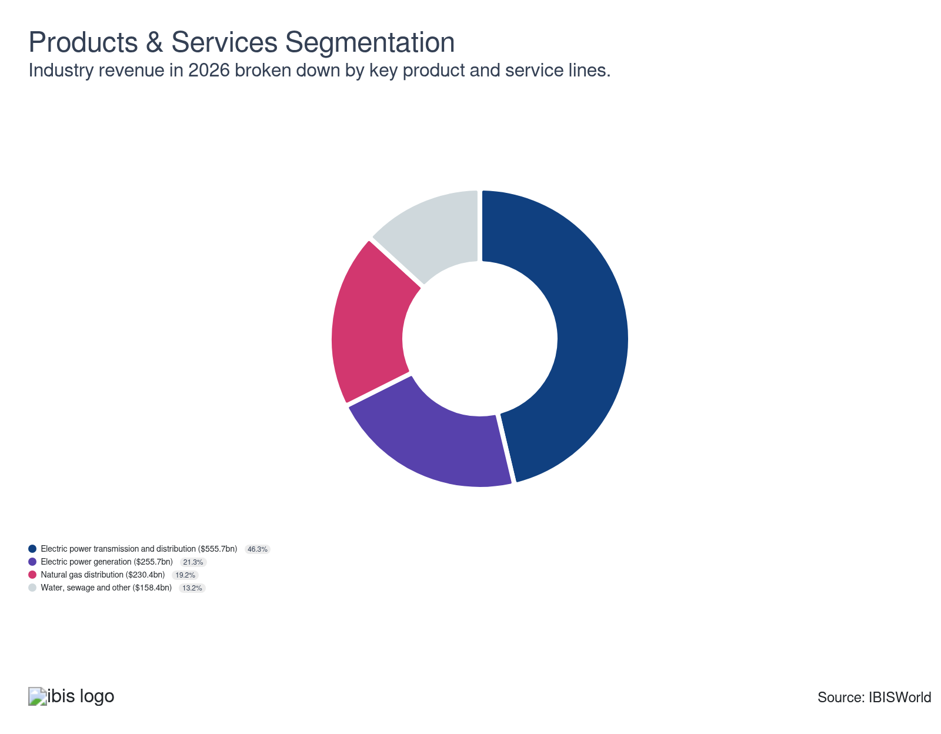

Major Players
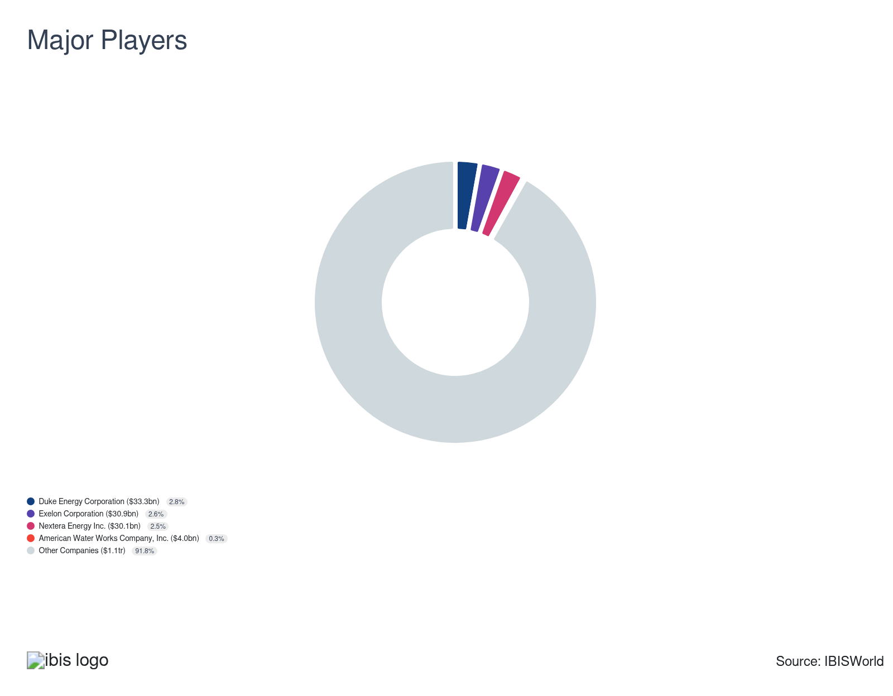

Key External Drivers
Key External Drivers | Impact
Electric power consumption | Positive
Price of electric power | Positive
Price of natural gas | Positive
Housing starts | Positive
Industrial production index | Positive
Regulation for the Utilities Sector | Negative

Industry Structure
Characteristic | Level | Trend
Concentration | Low
Barriers To Entry | High | Steady
Regulation and Policy | High | Steady
Life Cycle | Mature
Revenue Volatility | High
Assistance | Moderate | Steady
Competition | Low | Steady
Innovation | Moderate

SWOT
Strengths  High Profit vs. Sector Average  Low Customer Class Concentration  High Revenue per Employee | Weaknesses  High Volatility  High Product/Service Concentration  High Capital Requirements | Opportunities  High Revenue Growth (2021-2026)  High Revenue Growth (2026-2031)  High Performance Drivers  Electric power consumption | Threats  Low Revenue Growth (2005-2026)  Low Outlier Growth  Housing starts

Executive Summary

Equipped for anything: Increased electricity demand continues to boost revenue for the sector
The utility sector is currently experiencing transformative changes driven by unprecedented investments in renewable energy infrastructure, particularly in solar and wind projects. In 2023, the share of renewable energy in the US electric power generation has surged to over 20%, a significant climb from less than 10% just a few years ago. This shift is primarily supported by favorable tax credits to boost electricity production from sustainable sources. The sector is witnessing a resurgence in nuclear energy, exemplified by the commissioning of Vogtle Unit 3 in Georgia—marking the first new nuclear reactor in the US since 2016. Such developments signal a growing commitment to clean energy solutions and a strengthened focus on reducing environmental footprints across the nation. Overall, revenue has swelled at a CAGR of 2.7% through 2025, reaching $1.1 trillion, including a 2.9% uptick in 2025 alone.
This sector's growth can also be attributed to the significant climb in electric power prices and consumption. The remarkable spike in natural gas prices following the pandemic has also bolstered revenue. The higher costs of natural gas flowing through the distribution networks enhance profitability for natural gas distributors, contributing to the overall financial performance.
Key policy initiatives aimed at accelerating growth in the renewable energy sector while reducing utility costs and addressing climate change are expected to significantly impact the sector. As the transition to cleaner energy sources continues, coal's prominence will diminish, with natural gas will to remain a major energy option even as renewable energy captures a larger share of the market. The sector will also benefit from ongoing infrastructure investments to ensure access to clean drinking water and address drought challenges. The rising popularity of AI will also bolster nuclear power as large corporations ramp up reactors to power data centers. Nonetheless, dwindling electricity prices may hinder overall growth for power generators and transmitters. Despite these challenges, revenue is set to creep up at a CAGR of 0.5%, reaching $1.1 trillion by 2030.

3. Performance
https://my.ibisworld.com/us/en/industry/22/performance

Highlights
Revenue  $1.2tr  2021-26 CAGR ↑ 2.9 %  2026-31 CAGR ↑ 0.6 % | Employees  973k  2021-26 CAGR ↑ 0.9 %  2026-31 CAGR ↑ 0.6 % | Businesses  48,898  2021-26 CAGR ↓ 2.0 %  2026-31 CAGR ↑ 0.3 %
Profit  $398.5bn  2021-26 CAGR ↑ 3.3 % | Profit Margin  33.2%  2021-26 CAGR ↑ 0.7 pp

Key Takeaways
- Infrastructure advancements like smart grids and expanded EV charging stations are vital to the energy sector’s evolution. These innovations help optimize service and meet the growing electricity needs of a shifting consumer market.
- Utility companies are benefiting from rising power prices and increased consumption, driving revenue growth across the sector. Even with occasional economic dips, the need for electricity keeps these companies resilient and thriving.

Performance Snapshot
Revenue: | ↑ 2021-26 Revenue CAGR +2.9%
Revenue  $1.2tr  ’21-’26 ↑ 2.9 %  ’26-’31 ↑ 0.6 % | 2026 Revenue Growth  ↑ 2.0 % | Revenue Volatility  High
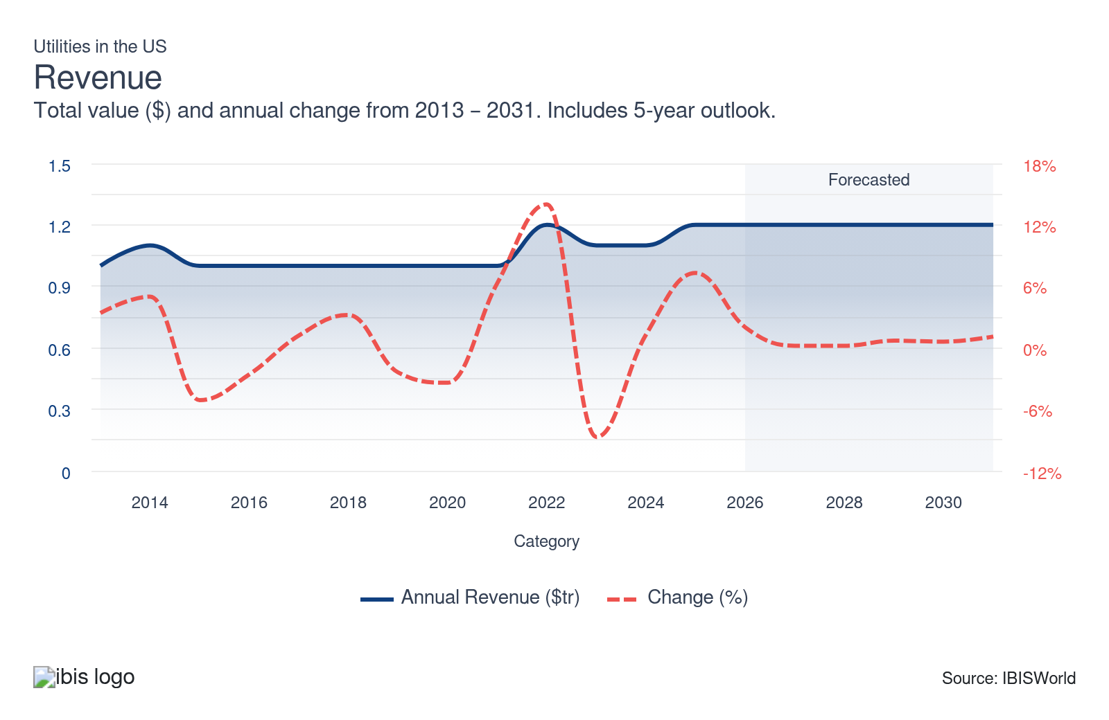
Employees: | ↑ 2021-26 Employees CAGR +0.9%
Employees  973k  ’21-’26 ↑ 0.9 %  ’26-’31 ↑ 0.6 % | Employees per Business  20  ’21-’26 ↑ 3.0 %  ’26-’31 ↑ 0.3 % | Revenue per Employee  $1m  ’21-’26 ↑ 2.0 %  ’26-’31 ↓ 0.0 %
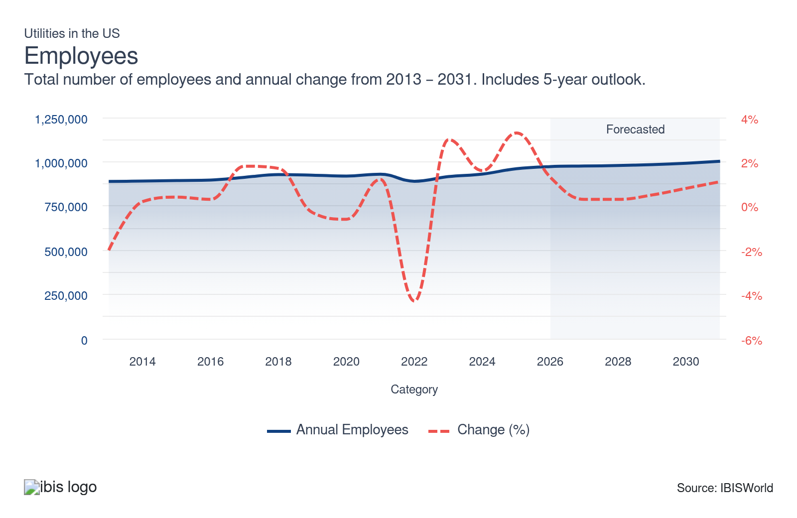
Businesses: | ↓ 2021-26 Business CAGR -2.0%
Businesses  48,898  ’21-’26 ↓ 2.0 %  ’26-’31 ↑ 0.3 % | Employees per Business  20  ’21-’26 ↑ 3.0 %  ’26-’31 ↑ 0.3 % | Revenue per Business  $24.5m  ’21-’26 ↑ 5.0 %  ’26-’31 ↑ 0.3 %
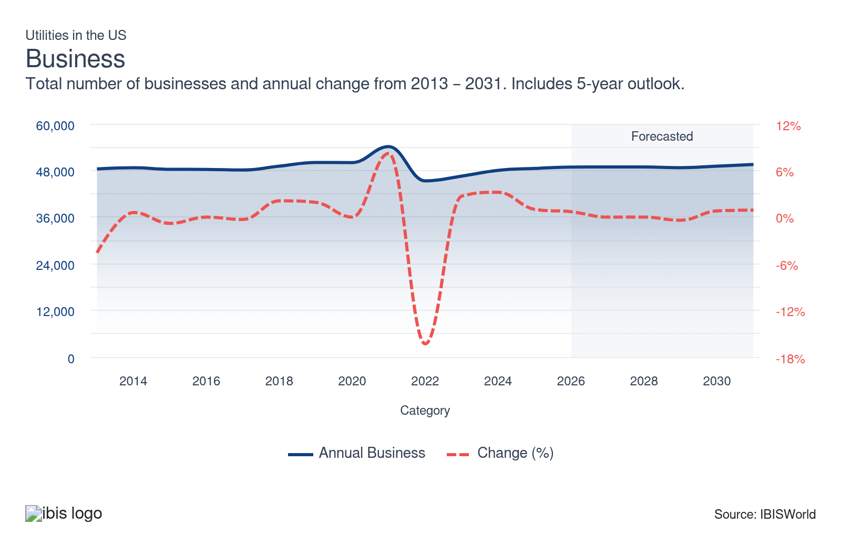
Profit: | ↑ 2021-26 Profit CAGR +3.3%
Total Profit  $398.5bn  ’21-’26 ↑ 3.3 % | Profit Margin  33.2%  ’21-’26 ↑ 0.7 pp | Profit per Business  $8.1m
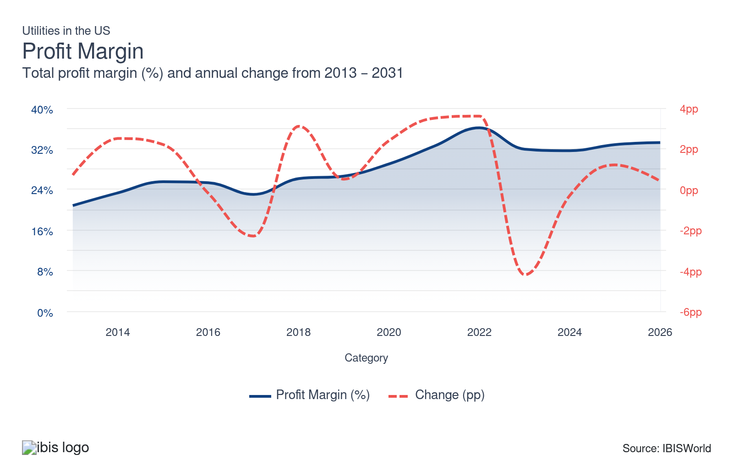
Current Performance
Current Performance

What's driving current industry performance?

The pathway to cleaner energy remains vital
- The US has poured an unprecedented amount of investment into renewable energy infrastructure, like solar and wind, to reduce the nation's environmental footprint and improve sustainability. Renewable generation companies, especially those that focus on solar and wind, have performed exceptionally well during the period as tax credits aimed at investment in producing electricity from these resources supported expansion.
- The rise in renewable energy's contribution to total US electric power is remarkable. From less than a tenth of electricity produced, it soared to over a fifth by 2023, according to the latest data available from the Energy Information Administration.
- While not as prominent, nuclear energy has also seen a resurgence lately because of its ability to provide energy for data centers to bolster the use of AI, in 2023, Vogtle Unit 3 in Georgia went live, making it the first new nuclear reactor since 2016. In 2024, construction for Vogtle Unit 4 concluded, boosting nuclear power for the foreseeable future. As of Fall 2024, Amazon, Google, Microsoft and Meta have entered deals or agreements to help revive old reactors or construct new small modular ones.
- Nonetheless, this growth in renewables came to a halt towards the end of the period as the One Big Beautiful Bill Act scaled back many tax incentives, making it less attractive for consumers and producers to invest in renewable energy.

Power generation, transmission and gas distribution remain the pillers for success
- The utility sector, an indispensable pillar of the economy, is segmented into enterprises that produce and delivery electric power, distribute natural gas, supply steam and water and provide sewage removal services.
- Electric power transmission, electric power generation cluster of industries and natural gas distribution generate the bulk of revenue. The development of these industries primarily relies on variations in electric power consumption, changes in electricity prices, pricing trends of resources utilized in power generation and evolution in the cost of natural gas.
- As power prices and consumption rose, utility companies experienced an uptick in revenue, reflecting a strong energy market and greater dependence on power utilities. Consumption and prices grew at a CAGR of 1.6% and 4.7% through 2025, respectively, boosting the sector. Natural gas has also seen massive price hikes, primarily after the pandemic, amid supply constraints, forcing generators and distributors to raise prices for their services to keep profit steady.

Infrastructure advancements help the sector advance
- Public utility commissions allow companies to raise electricity rates in exchange for investments in transmission infrastructure. The popularity of advanced metering technology, or smart grids, has surged. These grids offer real-time consumption data and enhance grid reliability, leading many companies to adopt this technology for service optimization. Smart-grid implementation also helps reduce construction and maintenance costs.
- In October 2023, the Biden Administration announced a $1.3 billion investment through the Bipartisan Infrastructure Law to expand transmission lines nationwide, adding 3.5 GW of grid capacity. In October 2024, the US DOE Grid Deployment Office announced a $1.5 billion investment in four new transmission projects through its Transmission Facilitation Program, which will aid in developing transmission lines, enhance grid resilience and make energy more affordable across the country.
- Infrastructure enhancements supporting electric vehicle (EV) charging stations and other electrification initiatives have bolstered electricity demand, benefiting generators as more consumers shift to electric options. Nonetheless, this sector has faced challenges. In February 2025, President Trump issued an executive order pausing about $3.0 million in funding for EV charging stations. As a result, transmission companies will need to seek alternative revenue sources to adapt to new regulations.

Economic conditions impact the vast utility sector
- As the economy rebounded in 2021, revenue expanded massively amid rapidly expanding gas and electricity prices. Even so, the industrial and commercial markets were still a bit slow to catch up as some factories operated at limited capacity and many businesses still had remote-work or hybrid-work policies in place.
- The ongoing war in Ukraine has contributed to a climb in natural gas prices, inadvertently boosting sector revenue. Sanctions imposed on Russia drastically reduced gas supplies, creating a shortage that inflated prices. However, these prices began to drop in 2023, leading to a stabilization of revenue. Utility companies typically price their products in line with overall commodity trends. Nonetheless, many generators or transmission companies will enter long-term supply and sales contracts to reduce risk and mitigate volatility.
- As power consumption continues to rise throughout 2026 and utility prices climb, companies are expected to raise the rates they charge customers, driving higher revenue and profitability. Profit growth will likely outpace revenue growth as utility companies introduce additional fees to fund infrastructure improvements.

What influences industry volatility?

Electricity and water are basic human rights and are readily accessible
- The need for electricity and water grows very slowly in the US since these utilities are widely accessible to the vast majority of residential and nonresidential consumers.
- Fluctuations in utility prices are another key factor contributing to revenue volatility. Even so, regulations are in place to prevent companies from engaging in price gouging and to ensure that pricing remains fair, stable, and aligned with consumer protection standards.

A shifting electricity disposition contributes to higher volatility
- Historically, fossil fuels have been the US's largest source of electric power. Natural gas and coal are the two most significant sources of electric power and collectively account for more than half of the total electricity produced in the country.
- Renewable energy generation methods like wind, solar and hydropower have expanded drastically, contributing to volatility. Renewable energy accounts for only a small fraction of the total electric power generated, limiting its impact on overall volatility.
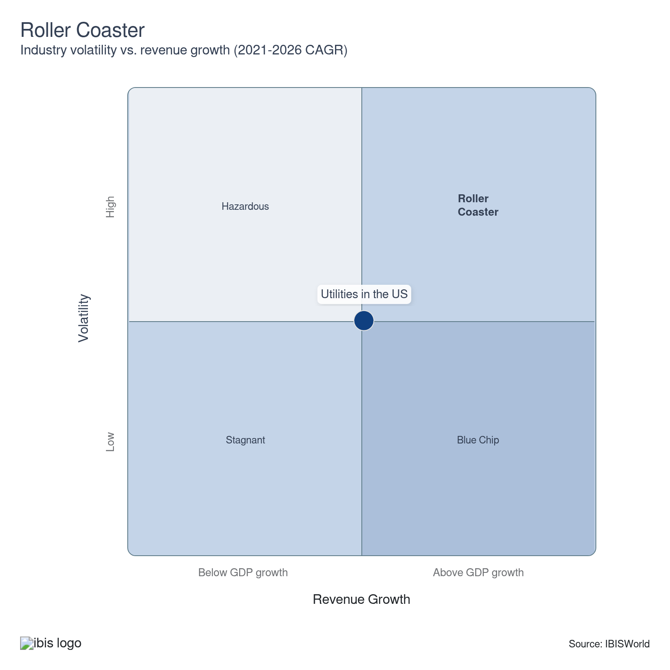

How do successful businesses overcome volatility?
Ability to pass on cost increases
In many states, regulatory policies have led to a competitive market for power generation. Market forces set wholesale electricity prices. However, retail price caps limit the extent to which cost increases can be recovered.
Develop links with suppliers
By developing strong relationships with suppliers, utility companies can secure stable pricing, ensure consistent supply and mitigate potential disruptions, thus overcoming volatility in availability and costs.
Outlook | ↑ 2026-31 Revenue CAGR +0.6%

What's driving the industry outlook?

Prices and consumption impacts revenue
- Over two-thirds of total sector revenue comes from electric power generation and transmission. The two most significant catalysts of electric power generation, transmission and distribution are the consumption of electric power and the price of electric energy.
- The price of electric power is set to push down through 2031. Efficiencies within the generation and transmission stages will also help to lower the cost of power. Alternative energy sources, like solar energy, will capture a larger share of power generation. As renewable energy production becomes more cost-effective, prices across the board will creep down.
- Electricity consumption will climb at a slower rate through 2031. However, as the economy grows, manufacturers and industrial producers will use more energy to produce goods for both domestic and export markets. This uptick will be somewhat offset by manufacturers moving overseas to cut costs and households using "smart devices" to monitor and reduce energy use. Based on these trends, utility companies will focus on securing industrial companies as customers and establishing long-term agreements with them, given their high energy consumption.

Recent government policies make renewables future uncertain
- The US has implemented new policies, regulations and market reforms aimed at lowering utility costs for families, bolstering the use of renewables and combatting climate change. The Inflation Reduction Act of 2022 is history's single-largest climate and energy investment. It allocated hundreds of billions of dollars through tax provisions and grant and loan programs to accelerate the growth of clean energy.
- States are also implementing their renewable portfolio standards to expand the use of renewables. These programs require a state to generate renewable energy as a certain percentage of its total energy portfolio. Currently, 28 states and Washington DC have implemented RPS goals or some other voluntary renewable targets and more states are continuing along this path.
- Nonetheless, the new Trump Administration recently passed Executive Order No. 3415 regarding halting wind power permits. While a recent extension allowed tax credits to remain in place until 2032, this was removed with the passage of the One Big Beautiful Bill. This bill ended the Residential Clean Energy Tax Credit at the end of 2025, so renewable systems must be installed on or before that date to qualify for the credit. Even so, state and regional incentives will remain, so it's not a total loss. While production tax credits remain for producers, those are set to expire at the end of 2026.
- Other renewable energy sources, like hydropower, geothermal and biomass, are set to improve. While these energy sources are more limited in nature, they are still expected to see some semblance of growth thanks to tax incentives. The main focus for these producers will be upgrading their facilities to generate more electricity. Nonetheless, they'll probably still generate a small portion of revenue as currently, the three combined only account for 7.2% of electricity generated in the country.

What's in store for coal, gas and nuclear?
- While coal has historically been the largest electric power source in the US, it has fallen from grace. It will continue to do so as the US invests heavily in decarbonizing its economy. Natural gas is the preferred energy source for electric power, heating and industrial processes in the US.
- Many coal plants nationwide are shutting down or transitioning to gas. While the US continued to retire coal plants last year, in December 2025, the Department of Energy made an emergency decision to keep five coal-fired plants active for at least 90 days. This trend began in early 2025 and has continued. While coal has been dipping as a share of revenue, the future is more uncertain if many retirements push back down the line. Although natural gas is relatively abundant and efficient compared with oil or coal, renewables will inevitably encroach on gas's stranglehold in the sector.
- While nuclear power has been controversial because of its associated risks, its low emissions have led to a resurgence, with two new plants opening in 2023 and 2024. The Department of Energy (DOE) is actively working to bolster the country's supply of high-assay, low-enriched uranium to enhance nuclear reactor technology.
- Nuclear power, in particular, is expected to see an uptick through 2031 as a result of the growing popularity of AI. AI-driven applications rely on large data centers that consume substantial energy, requiring a dependable and consistent power supply for efficient operation. With many large corporations, such as Meta, Google and Amazon, entering contracts to enhance nuclear power capacity, this segment will likely climb as plant operators engage in these power purchase agreements.

The other aspects of the utility sector
- The other segments of the utility sector include water supply and irrigation systems, sewage treatment facilities and steam and air-conditioning supply companies. With utility construction projected to expand through 2030, this growth will benefit companies specializing in these areas.
- The recently passed Bipartisan Infrastructure Law will invest $55.0 billion to expand cleaner drinking water for households, businesses and public entities nationwide. The investments will go toward improving water infrastructure and eliminating lead service pipes. The bill is also set to find ways to fight back against droughts in the West. Even so, with many companies focusing on water conservation, many water supply and sewage treatment facilities may see a constraint in growth.
- Regulations from the Environmental Protection Agency (EPA), like the first-ever national drinking water standard for per- and poly-fluoroalkyl substances (PFAS) and the Lead and Copper Rule Improvements (LCRI), will require companies to take action and upgrade their facilities. The LCRI mandates that public water systems eliminate lead pipes within ten years and reduce the lead action level from 0.015 mg/L to 0.010 mg/L. These upgrades may lead companies to raise prices for customers in order to remain profitable.
- Similarly, sewage treatment facilities will face challenges as the demand for cleaner water prompts new regulations in certain states. Recently, California passed a law mandating that wastewater be recycled for drinking. Companies are likely to partner with private ownership groups to help fund these upgrades and ensure compliance with standards.
Life Cycle | Mature

Why is the industry mature?

Contribution to GDP
The utility sector is pivotal in contributing to the nation's GDP. As providers of essential services like water, gas and electricity, they generate stable revenues despite economic fluctuations, which helps maintain GDP growth.

Market Saturation
Despite the essentiality, the utility sector faces high market saturation. With most homes and businesses already connected to utilities, growth opportunities primarily come from increased usage or infrastructure updates rather than new customer acquisition. In recent years, companies have focused more on targeting industrial clients because of their high volume energy usage.

Innovation
Innovation is significantly impacting the utility sector's stage. It's driving a shift from traditional centralized utility models to more efficient and sustainable models, like renewable energy sources or smart grids, opening new growth opportunities for existing utility companies.

Consolidation
Market share concentration is low, given the highly regulated nature of the sector. Consolidation is low since utility companies tend to serve only local and regional markets. Typically, companies do not like to operate outside of their regional area since they are subject to different laws and regulations.

Technology & Systems
The adoption of advanced technology and systems is influencing the sector's evolution. Smart meters, grid automation and data analytics help to enhance the efficiency and reliability of utility services. Even so, some residential customers are also leaning on the same technology to reduce electricity and water consumption

4. Products and Markets
https://my.ibisworld.com/us/en/industry/22/products-and-markets
Largest Market  $555.7bn  Electric power transmission and distribution | Product Innovation  Moderate

Key Takeaways
- Natural gas distribution's revenue is sensitive to market fluctuations, making it a volatile part of the sector. Companies must carefully navigate these price changes to maintain stability and profitability in their operations.
- Commercial and industrial markets consume the most power and gas. Despite this, residential consumers generate more revenue because of higher utility service prices than commercial and industrial users.

Products and Services
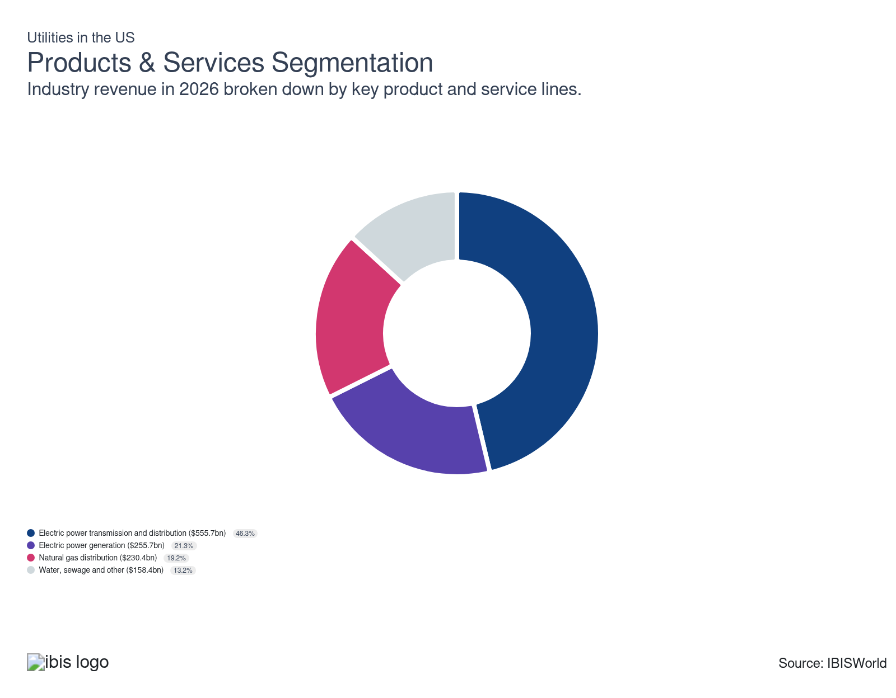

How are the industry’s products and services performing?

Electric power transmission is the sector’s leading provision
- Electric power transmission (IBISWorld report 22112) is the process of transporting power from its production source to end users. It involves operators of transmission lines, transformer stations, power lines, poles, meters and wiring.
- Electric power distribution systems effectively act as an intermediary, connecting high-voltage transmission systems from power-generating facilities to lower-voltage distribution lines, which break down power into a more consumable form for end users.
- While this segment continues to generate the most revenue, it has slightly dropped because of the growing investment interest in renewable electricity generation businesses. Nonetheless, there is a lot of funding available for this industry, primarily stemming from the Bipartisan Infrastructure Act and the Transmission Facilitation Program, so the drop-off shouldn't be too much.

Electric power generation continues to make its mark
- Electric power generation (22111a-e) represents the process of transforming energy from fossil fuels and renewable resources into electricity for use by consumers and industries. Businesses in these industries sell to wholesalers and distributors.
- Although coal has historically been the dominant source of power generation in the United States, it was surpassed by natural gas in 2016, marking a significant shift towards cleaner energy sources. Solar and wind energy are now the fastest-growing segments in the power generation sector, highlighting the transition towards sustainable energy alternatives.
- Despite its cost efficiency and low carbon emissions, nuclear power has not seen much growth, but recently, two plants were built in Georgia, which will aid this section moving forward. The fast-growing popularity of AI will also bolster nuclear power as many large corporations like Amazon, Google, Microsoft and Meta are investing in reviving old reactors or building new small ones.

Natural gas distribution hinges on underlying prices
- This segment consists of companies that operate gas distribution systems, marketers that buy gas from wells and sell it to distribution systems, brokers that arrange the sale of gas in a distribution system and companies that transmit and distribute gas to final customers.
- This segment is more volatile because revenue is tied to the fluctuating prices of natural gas. Distributors earn higher revenue when the value of the gas they ship increases. Although the price of natural gas has varied over the period, it has since stabilized, contributing to greater steadiness in this segment.

The need for water, sewage, steam and air conditioning is stable
- This segment consists of companies that operate water treatment plants (NAICS 22131), maintain sewer and sewage treatment facilities (22132) and supply steam and heated or cooled air (22133). These industries enjoy a lower level of volatility relative to the other industries in the sector.
- Even so, its revenue share has declined because of the climb in electric power generation and natural gas distribution. The sustainability of water, sewage, steam and air conditioning companies is essential for society's health and comfort, making it crucial to understand and address their challenges.

What are innovations in industry products and services?

Enhanced efficiency of combined-cycle power plants
- Over the past several decades, gas-fired power plants have become much more efficient at producing electricity. In 2000, the average capacity of a natural gas-fired combined-cycle power block was less than 400.0 megawatts. In 2019, the Energy Information Administration released data stating the national average now exceeds 800.0 megawatts.
- Almost three-quarters of all combined-cycle power plants use duct burners to expand the electricity generated by the system's steam turbine. Typically, a combined-cycle system consists of two gas turbines and one steam turbine, the industry's most common configuration.

Renewable energy innovations
- The primary objective of utility companies is to provide clean, affordable power and water to residential and commercial consumers. While fossil fuels have historically dominated, they have slowly lost their grip amid the growing popularity of renewable energy.
- Before 2009, renewable energy accounted for less than a tenth of electricity generation in the US. However, it has rapidly grown and currently makes up more than a fifth of electricity generated.
- While the current period saw renewable energy grow massively, this is set to slow down through 2031. The One Big Beautiful Bill Act removed residential tax credits for various energy sources in 2025 and is set to end production tax credits in 2027, slowing growth from these resources.

What products or services do successful businesses offer?
Ensure pricing policy is appropriate
In general, state governments set maximum retail electricity prices. Operators must adhere to these prices or encounter fines and legal problems.
Ability to negotiate successfully with regulator
Sector companies are regulated by several government organizations, and operators’ performance is contingent upon their ability to receive favorable rulings from regulators.
Successful adoption of smart grids and other efficient transmission technology
Utility operators take on large costs when investing in capital and sourcing or generating electricity or other industry services, so adequate financial and debt management is of paramount importance.

Major Markets
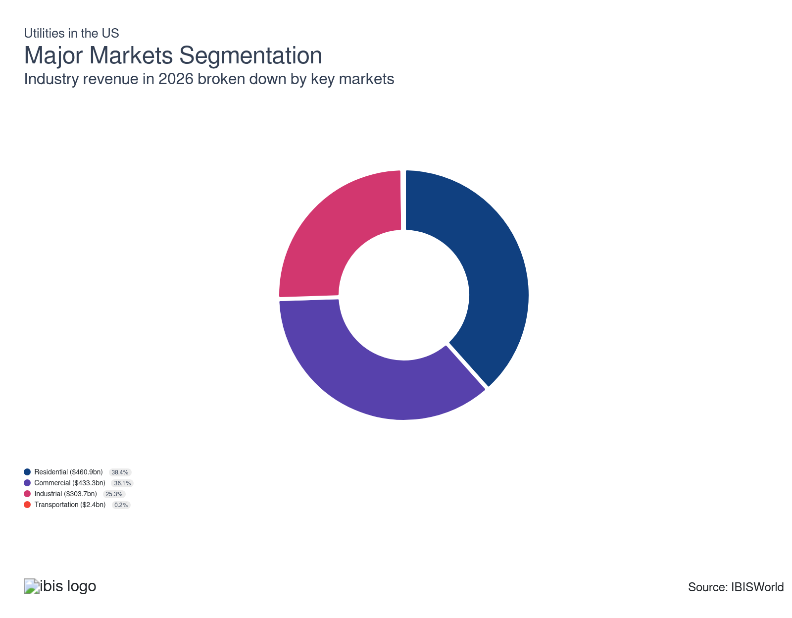

What’s influencing demand from the industry’s markets?

The residential market continues to dominate
- Utility companies provide households with essential goods and services, including electricity, water, heat and air conditioning. Since these are necessities, this market has remained stable despite economic hiccups. Despite households consuming fewer utilities than businesses per capita, more revenue is generated from the residential market than any other market because of the higher prices charged to this specific consumer group.
- This segment causes a temporary spike at the start of the period because of the swelling popularity of remote work and homeschooling. Even so, as workers and students resumed in-person activity, revenue slowly returned to normal, causing its share to weaken again, especially amid a halt in housing starts in 2026. Through 2031, this segment may continue to drop as homeowners adopt smart devices to reduce electricity and water usage.

Commerical consumers are back on track
- The commercial market encompasses service-providing businesses such as offices, shopping malls, hospitals and schools. These businesses are significant consumers of utility services. While this segment experienced a drop during the lockdowns, it has gradually recovered as businesses have returned to in-person operations. The number of businesses has also crept up, providing utility companies with a larger customer base.
- Many commercial businesses have signed long-term power purchase agreements with renewable energy providers to enhance sustainability, maintaining this segment at about a third of their revenue.

The industrial market benefits from bulk purchases
- The industrial market encompasses all services provided to manufacturers and other industrial operators. It also includes natural gas supplied to electric power generation companies that produce electricity using this resource.
- The industrial sector has placed a significant emphasis on renewable energy sources and water conservation, influencing the composition, consumption and pricing of utilities. While customers in this market consume a significant amount of electricity, they benefit from lower prices by purchasing in bulk to minimize costs. Nonetheless, with recent data centers popping up with the rise of AI, this segment may continue to push up as a share of revenue.

Transportation is small but steady
- The transportation market accounts for a tiny share of total sector revenue. Most of this revenue comes from using natural gas or electricity to power some automobiles, aircraft and trains.
- While the trend of electric vehicles holds promise, it has not significantly affected the transportation sector's contribution to total revenue, which has remained steady throughout the period.

International Trade

Some industries don't directly import or export goods. See reports at the manufacturing level for international trade data on relevant products.

5. Geographic Breakdown
https://my.ibisworld.com/us/en/industry/22/geographic-breakdown

Key Takeaways
- The Southwest is recognized as the energy capital of the world. Its rich natural gas reserves and a booming population have led to a high concentration of utility providers in this region.
- The abundance of natural resources in a region can be a significant attraction for utility companies. Some areas may provide a favorable regulatory environment and robust infrastructure, making them appealing locations for these businesses.

Business Locations
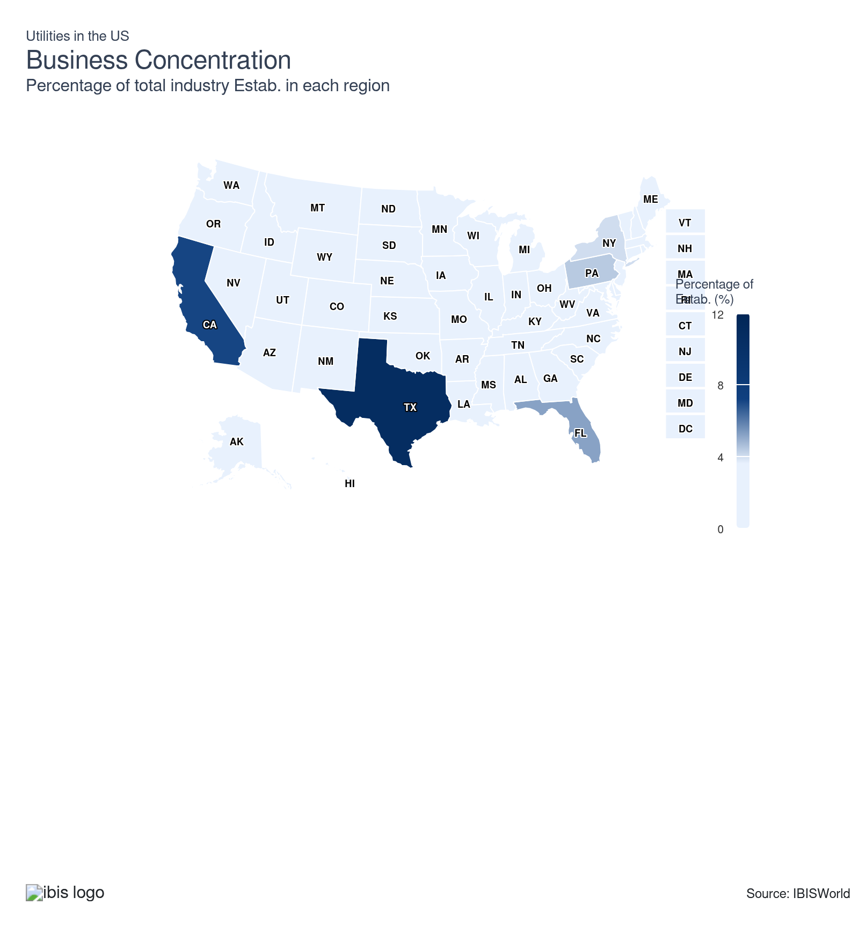
State | Estab.  Units | Estab.  % | Population  %
Texas | 2188 | 2.9 | 9.4
California | 1449 | 1.9 | 11.5
Florida | 1068 | 1.4 | 7.0
Pennsylvania | 900 | 1.2 | 3.8
New York | 824 | 1.1 | 5.8
Ohio | 736 | 1.0 | 3.5
Illinois | 701 | 0.9 | 3.7
North Carolina | 656 | 0.9 | 3.3
Indiana | 550 | 0.7 | 2.0
Mississippi | 554 | 0.7 | 0.9
Georgia | 496 | 0.7 | 3.3
Louisiana | 500 | 0.7 | 1.3
Iowa | 467 | 0.6 | 0.9
New Jersey | 444 | 0.6 | 2.8
Colorado | 438 | 0.6 | 1.8
Michigan | 431 | 0.6 | 3.0
Missouri | 419 | 0.6 | 1.8
Oklahoma | 417 | 0.6 | 1.2
Minnesota | 381 | 0.5 | 1.7
Virginia | 388 | 0.5 | 2.6
South Carolina | 360 | 0.5 | 1.6
Wisconsin | 377 | 0.5 | 1.7
Kentucky | 356 | 0.5 | 1.3
Washington | 345 | 0.5 | 2.3
Alabama | 279 | 0.4 | 1.5
Arkansas | 335 | 0.5 | 0.9
Massachusetts | 336 | 0.5 | 2.1
Arizona | 313 | 0.4 | 2.2
Oregon | 312 | 0.4 | 1.2
Kansas | 272 | 0.4 | 0.9
Maryland | 242 | 0.3 | 1.8
New Mexico | 235 | 0.3 | 0.6
West Virginia | 245 | 0.3 | 0.5
Idaho | 215 | 0.3 | 0.6
Utah | 223 | 0.3 | 1.0
Montana | 199 | 0.3 | 0.3
Tennessee | 181 | 0.2 | 2.1
Connecticut | 169 | 0.2 | 1.1
North Dakota | 159 | 0.2 | 0.2
South Dakota | 162 | 0.2 | 0.3
New Hampshire | 133 | 0.2 | 0.4
Wyoming | 143 | 0.2 | 0.2
Alaska | 113 | 0.2 | 0.2
Maine | 126 | 0.2 | 0.4
Nevada | 127 | 0.2 | 1.0
Nebraska | 107 | 0.1 | 0.6
Delaware | 87 | 0.1 | 0.3
District of Columbia | 78 | 0.1 | 0.2
Hawaii | 78 | 0.1 | 0.4
Vermont | 66 | 0.1 | 0.2
Rhode Island | 45 | 0.1 | 0.3

Where are industry businesses located?

The Southeast has the largest concentration of utilities companies
- The Southeast region of the United States boasts the highest concentration of establishments operating in the Utilities sector, accounting for over a quarter of companies. Given the universal need and use of utility services across various economic spheres, the distribution of these utility companies mirrors population density patterns.
- States including Alabama, Florida, Georgia, Louisiana, Mississippi, North Carolina and Virginia predominantly source their power from natural gas. Arkansas, Kentucky and West Virginia rely more on coal as their primary power source. South Carolina and Tennessee primarily derive their electricity from nuclear power.
- The region also has a warm climate, which leads to high energy usage, particularly for cooling, which supports the presence of multiple utility providers. Many states in the Southeast have historically utilized decentralized systems, with multiple smaller utility companies serving different regions or communities. Florida leads the pack with 5.2% of all utility companies, making it the third-largest in the country.

The Southwest is the energy capital of the world
- The Southwest, hailed as the global hub for energy, ranks second in the number of establishments in the utilities sector, mainly because of its rich natural gas reserves and large population concentration. This reflects that many natural gas distributors and electric power transmission companies in the oil and gas arena are centralized within this area, primarily in Texas, which leads the country with 10.7% of all utility establishments.
- Although the Southwest might not be as well-known, its extensive distribution networks and comprehensive access to the entire energy supply chain make it an excellent location for utility companies.
- Texas has a deregulated electricity market, particularly in most areas outside municipally owned utilities and cooperatives. This allows multiple retail providers to compete, leading to more utility companies. The region's climate and location are also suitable for wind and solar energy. Texas hosts the largest number of wind power producers and the third largest number of solar power producers.

The Great Lakes consume a great amount of power
- The populous and industrially prominent Great Lakes area demands substantial electricity, gas and other utility services. The region accounts for the third-largest number of establishments in the country, at 13.7%. Illinois boasts the highest density of utility companies compared to other states in this region.
- Coal is the primary energy source for Indiana, Michigan and Wisconsin. Meanwhile, nuclear energy predominates in Illinois, whereas Ohio relies heavily on gas-fired plants for power generation. However, this segment may be at risk through 2030, as many states are shutting down coal plants as a result of carbon emissions. Even so, many plants in the region may transition to other energy sources while keeping the facilities intact.
- With its large population, the region is a hub for the industrial sector, particularly automobile manufacturers. These companies consume substantial amounts of energy, making it an ideal location for utility companies to secure new contracts.
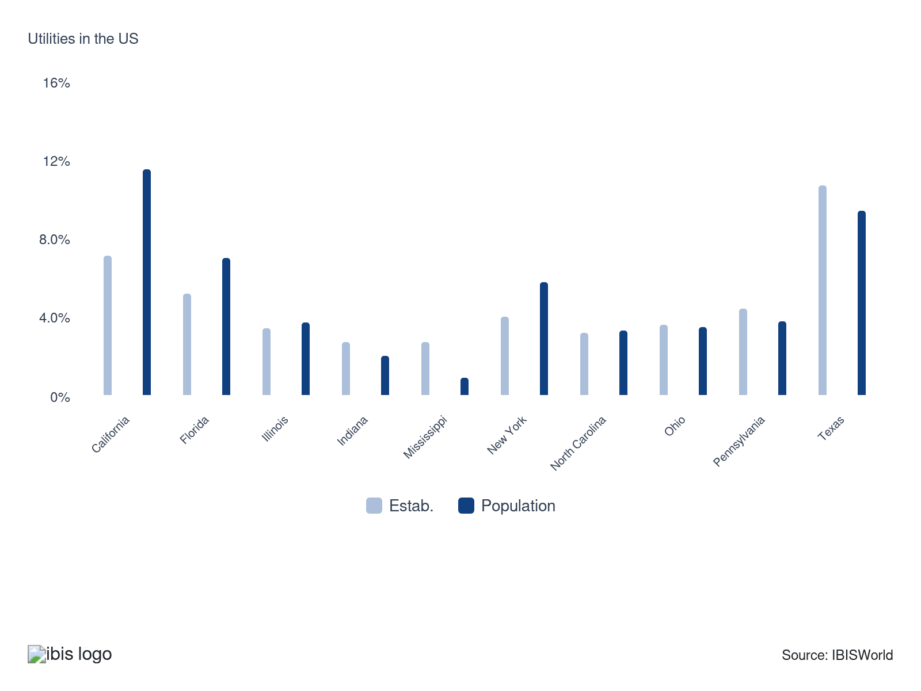

How do businesses use location to their advantage?
Ensure pricing policy is appropriate
In general, state governments set maximum retail electricity prices. Operators must adhere to these prices or encounter fines and legal problems.
Ensure resource availability
Utility companies use location data to optimize infrastructure planning, ensuring resources like water and power are readily available where needed and addressing service disruptions in a timely manner.

6. Competitive Forces
https://my.ibisworld.com/us/en/industry/22/competitive-forces

Key Takeaways
- Internal competition heats up with the growing prevalence of independent power producers (IPP). IPPs provide competition and choice for consumers and help to meet growing demand for low-cost electricity.
- Consumers are gaining more buying power in the energy market, especially in deregulated areas. The ability to choose providers based on cost and energy sources drives competition and pushes for cleaner options.

Concentration
Low
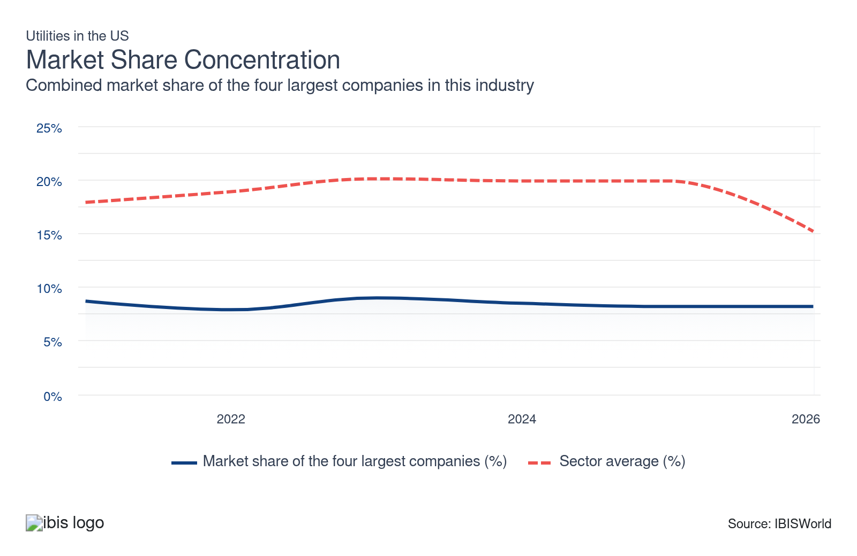

What impacts the industry’s market share concentration?

Regulations surrouding the industry
- In traditional energy markets, vertically integrated utilities are responsible for overseeing all stages of the energy delivery process. This includes generation, transmission and distribution. Natural monopolies exist in traditional energy markets.
- In deregulated markets, the Federal Energy Regulatory Commission (FERC) has granted independent power producers the authority to tap into regulated transmission systems. As of 2026, there are 32 states that offer deregulated energy.

Low, regional concentration exists within the sector
- Market share concentration is low since utility companies tend to serve only local and regional markets. The utilities sector is one of the economy's most capital-intensive segments; few companies have the finances to expand beyond the immediate region. The four largest companies account for less than one-tenth of total sector revenue.
- The shift towards renewable energy sources has led to an uptick in smaller, independent producers, diversifying the market. This has lowered concentration as more companies emerge, including solar, wind and biomass producers. Nonetheless, this may slow down after 2027 as investment tax credits expire early from the One Big Beautiful Bill Act.

How do successful businesses handle concentration?
Ensure pricing policy is appropriate
In general, state governments set maximum retail electricity prices. Operators must adhere to these prices or encounter fines and legal problems.
Develop a strong reputation
Utility companies can strengthen their reputation by maintaining consistent, reliable services, incorporating sustainable practices, continuously innovating and prioritizing excellent customer service, even amid a concentration market.

Barriers to Entry
High | Steady

What challenges do potential industry entrants face?

Legal
- The utility sector experiences significant legal challenges related to regulatory and environmental compliance and balancing public and private interests. This sector experiences a higher level of regulation relative to other sectors of the domestic economy.

Start-up Costs
- Utility companies encounter significant start-up costs, which are heavily influenced by the type and location of the power plant or water station. Regulatory compliance and environmental assessments can further heighten these costs, as companies may need to implement certain technologies to reduce waste or emissions.

Differentiation
- Utility companies differentiate themselves through pricing, customer service, technology and innovation, sustainability, range and accessibility. The type of resources used and the region a company operates in can make all the difference.

Labor Expenses
- Highly-skilled engineers and technicians are absolutely necessary to ensure that a power plant or water facility is running safely and efficiently. Still, the Utilities sector is much more dependent on capital to purchase property and build infrastructure.

Capital Expenses
- Entering the utility sector requires hefty investments in infrastructure, like power plants and distribution networks. This significant capital requirement deters smaller companies, creating a steep financial barrier that favors established companies with deep pockets. This is why the sector typically has high and steady depreicaiton costs.

How can potential entrants overcome barriers to entry?
Ensure pricing policy is appropriate
In general, state governments set maximum retail electricity prices. Operators must adhere to these prices or encounter fines and legal problems.
Ability to negotiate successfully with regulator
Sector companies are regulated by several government organizations, and operators’ performance is contingent upon their ability to receive favorable rulings from regulators.

Substitutes
Low | Increasing

What are substitutes for industry services?

Solar Panel Installation
- Residential and nonresidential solar electric systems are growing in prevalence alongside improvements in solar photovoltaic technology.
- More power consumers are adding solar panels to their households or businesses to reduce energy bills, earn tax credits and combat greenhouse gas emissions. This reduces the need for energy produced by traditional power producers. Even so, the One Big Beautiful Bill Act is set to cut the timeline on tax credits, weakening this segment past 2026.

Vehicle-to-grid integration (V2G)
- V2G is an emerging technology that seeks to link transportation and electricity systems. This technology enables vehicles to store electricity and deploy the energy back to the grid when not in use.
- Vehicle-to-grid technology will help support load balancing and integration of renewable energy. It also has the potential to reduce energy costs and bolster grid stability by turning electric vehicles into distributed energy resources.

How do successful businesses compete with substitutes?
Ensure pricing policy is appropriate
In general, state governments set maximum retail electricity prices. Operators must adhere to these prices or encounter fines and legal problems.
Successful adoption of smart grids and other efficient transmission technology
Utility operators take on large costs when investing in capital and sourcing or generating electricity or other industry services, so adequate financial and debt management is of paramount importance.

Buyer & Supplier Power
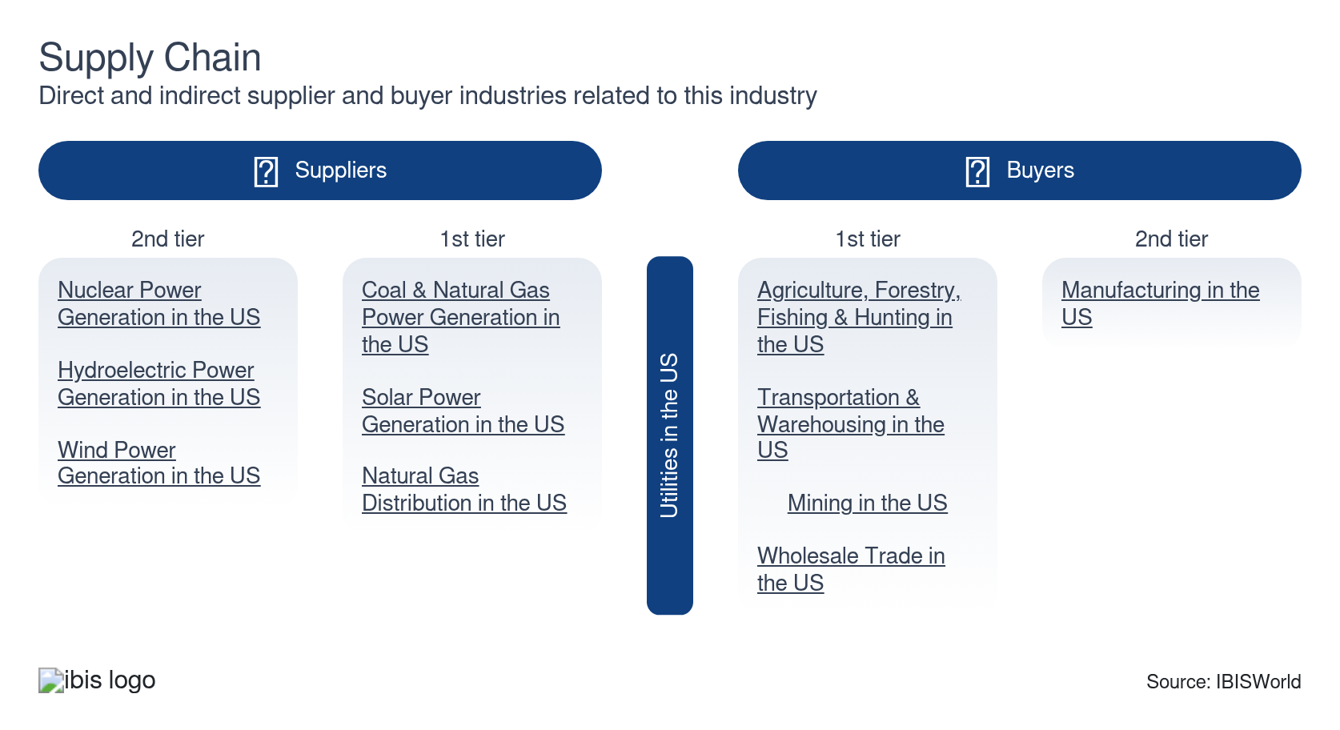

What power do buyers and suppliers have over the industry?

Buyers: Consumer choice for power grows
Moderate | Steady
- Consumers have a growing influence on power plants through their energy choices, consumption habits and environmental advocacy. Some consumers are also using smart devices to reduce their electricity and water usage.
- Consumers can choose their energy provider in deregulated markets based on cost and energy source. In contrast, the price and power source are set in regulated utility markets. Regulated markets are designed to give individuals stable and reliable access to electricity at a reasonable cost but often lead to a reduction in competition among market participants.

Suppliers: Power plants have low buying power
Low | Steady
- The main operating cost for power plants is the cost of fuel, including coal, natural gas and uranium. Power plants have little buying power over raw material suppliers, given that individual power plants typically do not make up a substantial portion of revenue for the suppliers.
- Renewable energy power producers like wind and solar companies purchase solar panels and turbines, which can be expensive. Even so, as technology advances, these materials' costs have slowly pushed down.

How do successful businesses manage buyer & supplier power?
Ability to pass on cost increases
In many states, regulatory policies have led to a competitive market for power generation. Market forces set wholesale electricity prices. However, retail price caps limit the extent to which cost increases can be recovered.
Ensure pricing policy is appropriate
In general, state governments set maximum retail electricity prices. Operators must adhere to these prices or encounter fines and legal problems.
Successful adoption of smart grids and other efficient transmission technology
Utility operators take on large costs when investing in capital and sourcing or generating electricity or other industry services, so adequate financial and debt management is of paramount importance.

7. Companies
https://my.ibisworld.com/us/en/industry/22/companies

Key Takeaways
- Tennessee Valley Authority is one of the nation’s largest public power corporation by generating capacity. Its Cumberland coal-fired power plant has a summer net capacity of 2.5 gigawatts.
- The Grand Coulee hydroelectric power plant has a summer capacity of 7.1 gigawatts. It is the single-largest electric generation facility by generation capacity.

Market Share
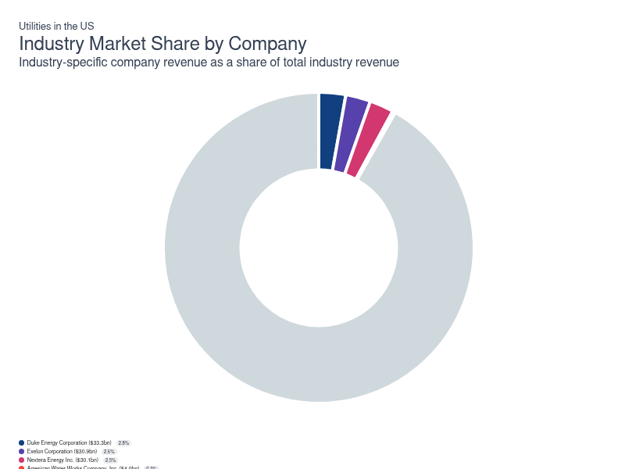
Chart displays current year only in the PDF version of this report. You can view and download chart for all other years associated with this industry on my.ibisworld.com.

Companies
Company | Market Share (%)  2026 | Revenue ($m)  2026 | Profit ($m)  2026 | Profit Margin (%)  2026
Duke Energy Corporation | 2.8 | 33,276.2 | 8,388.4 | 25.2
Exelon Corporation | 2.6 | 30,851.0 | 4,480.0 | 14.5
Nextera Energy Inc. | 2.5 | 30,125.1 | 9,921.3 | 32.9
American Water Works Company, Inc. | 0.3 | 4,019.0 | 1,378.0 | 34.3

Duke Energy Corporation
Duke Energy Corporation
Company Details
Company Details
Industry Specific Revenue (2026) | $33.3bn
Industry Profit (2026) | $8.4bn
Company Employees (2026) | 28,000
Market Share (2026) | 2.8%

Description
Description
Duke Energy is a public company headquartered in North Carolina with an estimated 28,000 employees. In the US, the company has a notable market share in at least three industries: Utilities, Coal & Natural Gas Power Generation, Wind Power Generation and Wind Power Generation. Their largest market share is in the Coal & Natural Gas Power Generation industry, where they account for an estimated 14.5% of total industry revenue and are considered a Disruptor because they display lower to medium market share that’s rising rapidly, but weaker profits compared to some of their peers.

Brands and Trading Names
Brands and Trading Names
- Duke Energy Carolinas
- Duke Energy Florida
- Duke Energy Indiana
- Duke Energy Ohio Kentucky
- Duke Energy Progress
- Peidmont Natural Gas

Other Industries
Other Industries
- Coal & Natural Gas Power Generation in the US
- Wind Power Generation in the US

Company’s Industry Revenue, Market Share, and Profit Margin Over Time
Company’s Industry Revenue, Market Share, and Profit Margin Over Time
Year | Industry Revenue ($ million) | Market Share (%) | Profit Margin (%)
2021 | 24621 | 2.8 | 22.3
2022 | 28768 | 2.7 | 20.9
2023 | 29060 | 2.9 | 24.3
2024 | 30357 | 2.9 | 26.1
2025 | 32025 | 2.8 | 24.8
2026 | 33276 | 2.8 | 25.2

What's impacting Duke Energy Corporation's performance?

Total energy capacity and generation by source
- Duke Energy Corporation (Duke) is estimated to have 50.3 gigawatts of generation capacity in 2021. Of this capacity, 31.8% of energy was generated by natural gas and fuel oil in 2021, while 29.8% was generated by nuclear power for the year. The share of generation represented by these two sources has increased over the past several years on account of the corporation investing in clean power initiatives. Still, 18.2% of the company’s energy capacity was generated by coal in 2021, a percentage that has slowly waned over the past several years. Duke plans on closing all of its coal plants by 2035 and more than double its renewable generation capacity by 2030.

Company's road to achieving net-zero carbon emissions
- Duke’s clean energy strategy includes expanding upon the company’s existing portfolio of carbon-free technologies, including nuclear and renewables, to achieve net-zero carbon emissions by 2050. The organization’s nuclear generation fleet is central to its ability to achieve its mission to lower its carbon footprint. The company is actively seeking to extend the operating lives of its 11 nuclear reactors for an additional 20 years by renewing the operating license of each. Failure to receive approval for the relicensing of these facilities or changes in industry regulations may have a significant effect on the company’s financial condition.

Duke's current and future renewable energy initiatives
- Duke has a track record of growing its organization via making improvements to the nation’s electric grid. Some of the company’s most recent achievements include delivering 34.0 megawatts of battery storage across three locations in Florida. This project is expected to enhance the overall reliability and manageability of utility-sale solar generation. Additionally, the company intends on investing $100.0 million in electric vehicle charging infrastructure between 2021 and 2024. Duke’s ongoing investment in battery technology reflects its expectation that this technology will play a significant role in how customers interact with the nation’s electric grid.
Exelon Corporation
Exelon Corporation
Company Details
Company Details
Industry Specific Revenue (2026) | $30.9bn
Industry Profit (2026) | $4.5bn
Company Employees (2026) | 19,063
Market Share (2026) | 2.6%

Description
Description
Exelon is a public company headquartered in Illinois with an estimated 19,063 employees. In the US, the company has a notable market share in at least four industries: Utilities, Electric Power Transmission, Control & Distribution, Coal & Natural Gas Power Generation, Nuclear Power Generation and Coal & Natural Gas Power Generation. Their largest market share is in the Nuclear Power Generation industry, where they account for an estimated 45.4% of total industry revenue and are considered an All Star because they display stronger market share, profit and revenue growth compared to their peers.

Brands and Trading Names
Brands and Trading Names
- Atlantic City Electric
- BGE
- ComEd
- Constellation
- Delmarva Power
- Exelon Generation
- PECO
- Pepco

Other Industries
Other Industries
- Coal & Natural Gas Power Generation in the US
- Electric Power Transmission, Control & Distribution in the US
- Nuclear Power Generation in the US

Company’s Industry Revenue, Market Share, and Profit Margin Over Time
Company’s Industry Revenue, Market Share, and Profit Margin Over Time
Year | Industry Revenue ($ million) | Market Share (%) | Profit Margin (%)
2008 | 31663 | 4.0 | 10.2
2009 | 28874 | 4.1 | 10.2
2010 | 30317 | 4.1 | 10.2
2011 | 30967 | 4.2 | 10.2
2012 | 29274 | 4.1 | 10.2
2013 | 30890 | 4.1 | 10.2
2014 | 33271 | 4.2 | 10.2
2015 | 31671 | 4.2 | 10.2
2016 | 31360 | 4.2 | 10.2
2017 | 33558 | 4.3 | 13.1
2018 | 35978 | 4.4 | 10.8
2019 | 34438 | 4.3 | 12.7
2020 | 33039 | 4.2 | 8.5
2021 | 30851 | 3.5 | 14.5
2022 | 30851 | 2.9 | 14.5
2023 | 30851 | 3.0 | 14.5
2024 | 30851 | 2.9 | 14.5
2025 | 30851 | 2.7 | 14.5
2026 | 30851 | 2.6 | 14.5

What's impacting Exelon Corporation's performance?

Path to reducing climate change in the company
- Exelon is establishing goals to cut its greenhouse gas emissions over the coming years by modernizing the nation’s infrastructure and investing in clean equipment and vehicles. The organization’s current goal is to cut its emissions in half by 2030 and achieve net zero by 2050. It also has plans to electrify 30.0% of its vehicle fleet by 2025 and half of it by 2030. The company continues to invest in infrastructure and promote local and federal policies targeting decarbonization.
Nextera Energy Inc.
Nextera Energy Inc.
Company Details
Company Details
Industry Specific Revenue (2026) | $30.1bn
Industry Profit (2026) | $9.9bn
Company Employees (2026) | 9,300
Market Share (2026) | 2.5%

Description
Description
Nextera Energy is a public company headquartered in Florida with an estimated 9,300 employees. In the US, the company has a notable market share in at least three industries: Utilities, Wind Power Generation, Solar Power Generation and Utilities. Their largest market share is in the Solar Power Generation industry, where they account for an estimated 13.2% of total industry revenue and are considered a Rising Star because they display lower market share, but displaying stronger profit and revenue growth than some of their peers.

Other Industries
Other Industries
- Solar Power Generation in the US
- Wind Power Generation in the US

Company’s Industry Revenue, Market Share, and Profit Margin Over Time
Company’s Industry Revenue, Market Share, and Profit Margin Over Time
Year | Industry Revenue ($ million) | Market Share (%) | Profit Margin (%)
2021 | 17069 | 1.9 | 17.1
2022 | 20956 | 2.0 | 19.5
2023 | 28114 | 2.8 | 36.4
2024 | 24753 | 2.3 | 30.2
2025 | 27412 | 2.4 | 30.2
2026 | 30125 | 2.5 | 32.9

What's impacting Nextera Energy Inc.'s performance?

NextEra continues to expand its solar power capabilities
- In June 2024, NextEra announced a five-year partnership with Entergy to commence construction on various solar generation and energy storage projects, targeting a total capacity of up to 4.5 GW. This collaboration aims to deliver inexpensive renewable energy to meet the growing electricity needs in Arkansas, Louisiana, Mississippi and Texas while also building on existing projects already underway with Entergy. The initiative expands Entergy's renewable energy portfolio and provides NextEra with a steady revenue stream.

NextEra sets RealZero goal to eliminate carbon emissions
- NextEra released an announcement in June 2022 stating that it will completely revamp its operations to decrease its emissions. It has laid out a Zero Carbon Blueprint to aid the company in growing its renewable energy presence in the U.S. through the use of solar, nuclear, wind and other sources. The company also will continue using cost-saving energy sources to bring more energy to consumers. The company cited that this goal will help create over 100,000 positions, which will help grow the company.
American Water Works Company, Inc.
American Water Works Company, Inc.
Company Details
Company Details
Industry Specific Revenue (2026) | $4.0bn
Industry Profit (2026) | $1.4bn
Company Employees (2026) | 7,000
Market Share (2026) | 0.3%

Description
Description
American Water Works Company is a public company headquartered in New Jersey with an estimated 7,000 employees. In the US, the company has a notable market share in at least three industries: Utilities, Water Supply & Irrigation Systems, Sewage Treatment Facilities and Utilities. Their largest market share is in the Water Supply & Irrigation Systems industry, where they account for an estimated 3.4% of total industry revenue and are considered a Rising Star because they display lower market share, but displaying stronger profit and revenue growth than some of their peers.

Other Industries
Other Industries
- Sewage Treatment Facilities in the US
- Water Supply & Irrigation Systems in the US

Company’s Industry Revenue, Market Share, and Profit Margin Over Time
Company’s Industry Revenue, Market Share, and Profit Margin Over Time
Year | Industry Revenue ($ million) | Market Share (%) | Profit Margin (%)
2008 | 3334 | 0.4 | 32.9
2009 | 3040 | 0.4 | 32.9
2010 | 3192 | 0.4 | 32.9
2011 | 3261 | 0.4 | 32.9
2012 | 3082 | 0.4 | 32.9
2013 | 3253 | 0.4 | 32.9
2014 | 3503 | 0.4 | 32.9
2015 | 3335 | 0.4 | 32.9
2016 | 3302 | 0.4 | 32.9
2017 | 3357 | 0.4 | 37.3
2018 | 3440 | 0.4 | 32.0
2019 | 3610 | 0.4 | 32.4
2020 | 3777 | 0.5 | 33.0
2021 | 4019 | 0.5 | 34.3
2022 | 4019 | 0.4 | 34.3
2023 | 4019 | 0.4 | 34.3
2024 | 4019 | 0.4 | 34.3
2025 | 4019 | 0.3 | 34.3
2026 | 4019 | 0.3 | 34.3

What's impacting American Water Works Company, Inc.'s performance?

Customer growth fueled by utility system acquisitions
- American Water Works serves 3,269 water and 261 wastewater customers and served nearly 14.0 million individuals in 2021. Customer growth in the company’s regulated utility business has primarily been driven through acquisitions of existing utility systems and, to a lesser extent, through population growth in authorized service areas. In 2021, the company invested over $250.0 million to fund acquisitions of assets in New York and New Jersey that ultimately added nearly 20,000 water and wastewater customers to the company’s regulated businesses. American Water Works plans to spend between $1.5 and $2.0 billion over the next five years to complete more acquisitions and expand the company’s customer base.

Revenue stream disruptions occur during the COVID-19 pandemic
- Over the past several years, American Water Works Company Inc. (American Water Works) has encountered diverging demand patterns from its residential and nonresidential consumers on account of socioeconomic restrictions that change in severity on an ongoing basis. In general, residential water sales have grown during the COVID-19 pandemic as individuals have spent more time at home and increased utility usage. As a result, organic sales to commercial and industrial customers have come under pressure since many workplaces have been forced to scale back operations. The retracement of business restrictions is expected to benefit demand from nonresidential customers moving forward.

Authorized rate increases support revenue growth
- Since the outset of the current five-year period, American Water Works has benefited from authorized rate increases, including infrastructure surcharges. Rate adjustments are allowed periodically to reflect recovery of capital investments made into replacing the infrastructure which is necessary to sustain safe and reliable services for customers. Moving forward, it will be essential for American Water Works to earn rate increases so the organization can cover the capital expenses used to upgrade aging infrastructure. American Water Works estimates it to have earned $208.0 million from authorized rate increases in 2021 alone.

You can view and download company details on my.ibisworld.com.

8. External Environment
https://my.ibisworld.com/us/en/industry/22/external-environment

Key Takeaways
- Utilities is one of the most heavily regulated sectors of the US economy. Businesses must comply with a myriad of regulations that make it extremely costly to do business.
- The Infrastructure Investment and Jobs Act significantly pushes towards a zero-emissions future. With investments like $55 billion aimed at clean drinking water, it's clear the US is serious about upgrading its energy infrastructure.

External Drivers

What demographic and macroeconomic factors impact the industry?
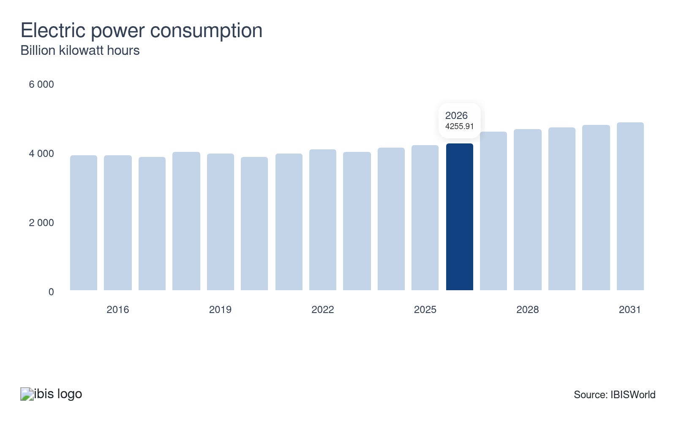
Electric power consumption represents the total amount of electricity consumed in the United States. The utility sector generates, transmits and distributes all electric power in the United States. Electric power consumption positively correlates with sector revenue; revenue rises when more power is sold to consumers, representing a potential opportunity for the sector.
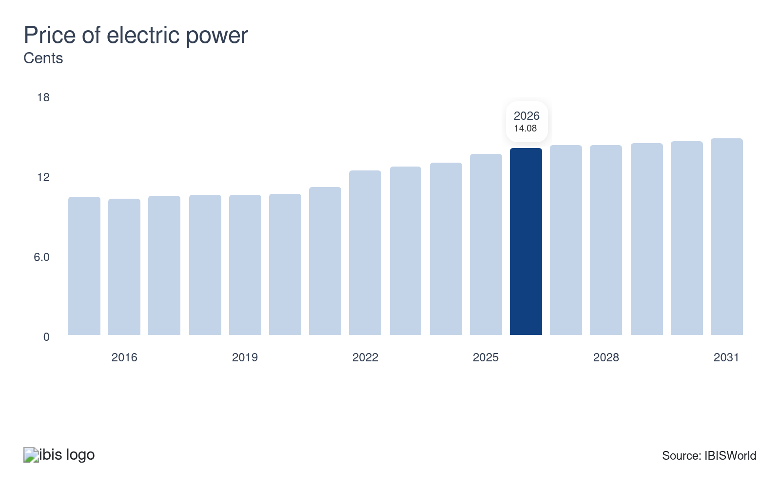
The price of electric power represents the average price of electricity purchased by residential, commercial, industrial and transportation customers in the United States. Sector revenue is positively correlated with the price of electric power because electric generators and distributors earn greater revenue when they charge more for the same amount of energy.
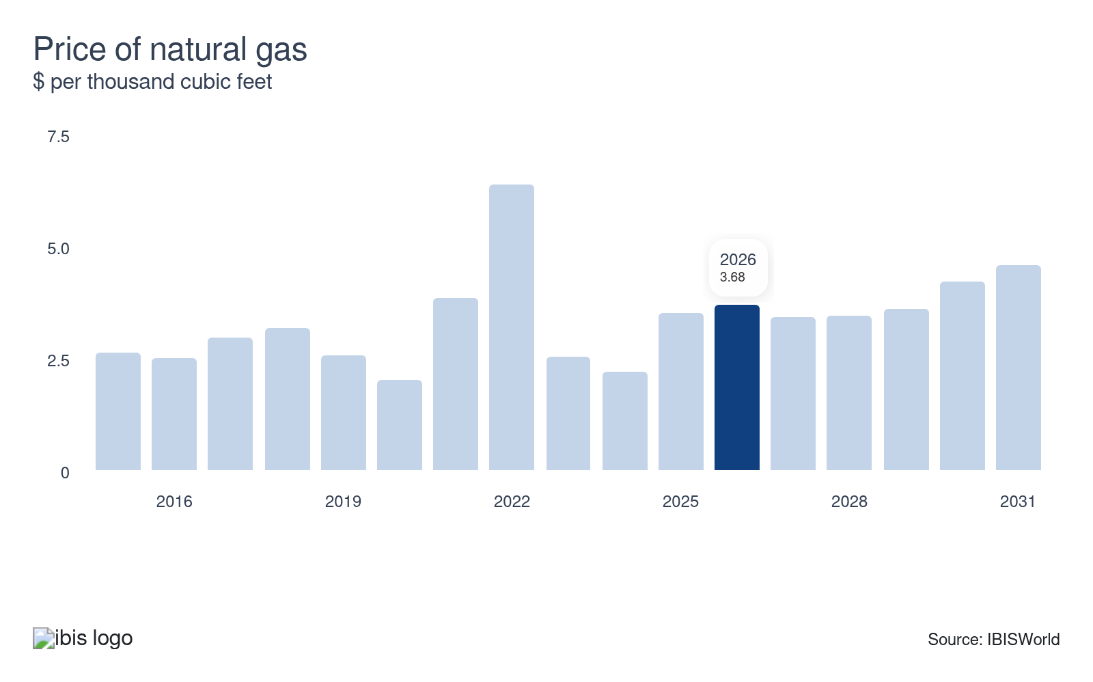
Natural gas distributors earn a percentage of the gas sold and transmitted through their vast network of pipelines. Sector revenue benefits when the price of natural gas increases and gas distributors, marketers and brokers earn more revenue from the same quantity of gas sold and transmitted through the system.
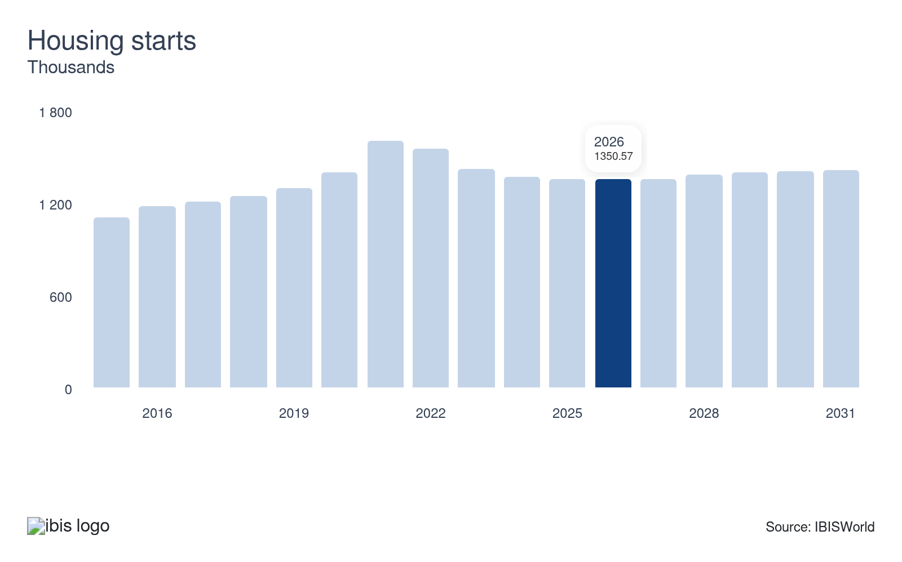
Housing starts indicate the number of new residential homes under construction. An uptick in housing starts to drive the need for sector services because all products and services are staples in homes. When housing starts drop or remain stagnant, it can weaken growth from one of the sector's largest markets, posing a potential threat to utility providers.
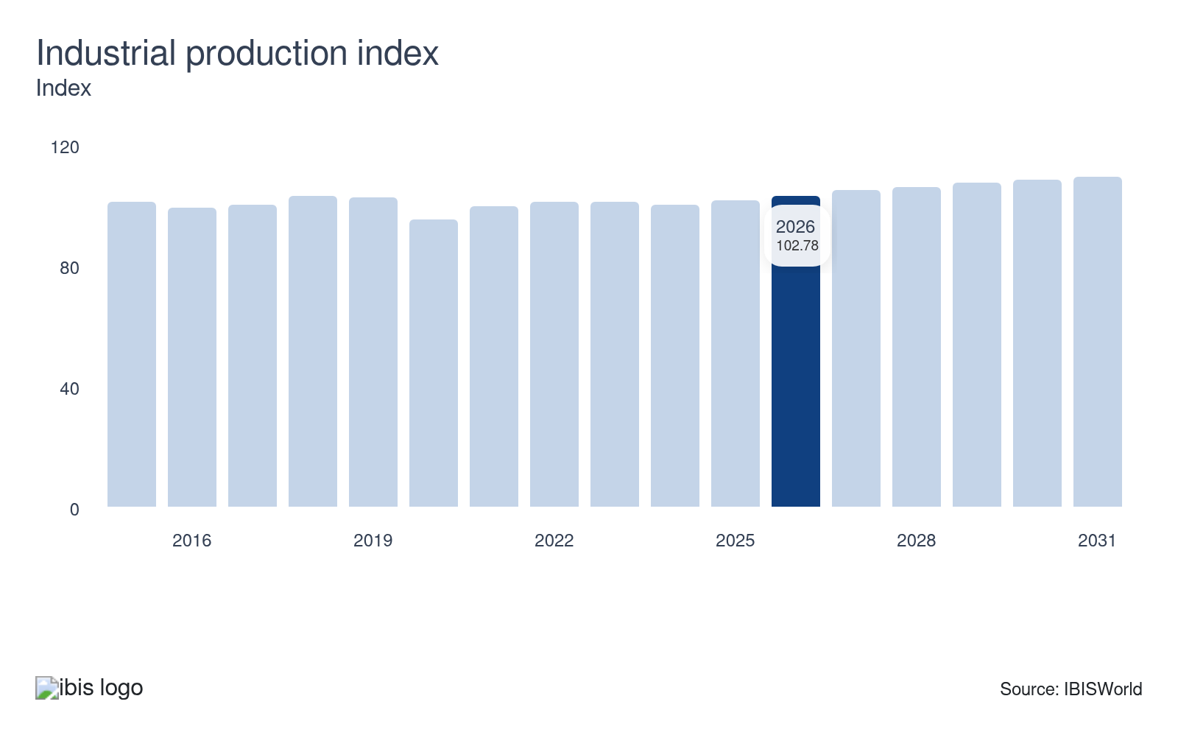
Industrial use of utilities accounts for a sizable portion of sector revenue. An uptick in industrial production benefits the sector as more utilities are needed to support industrial growth. The industrial sector is the third-largest market and often buys electricity in bulk, allowing it to benefit from lower prices.
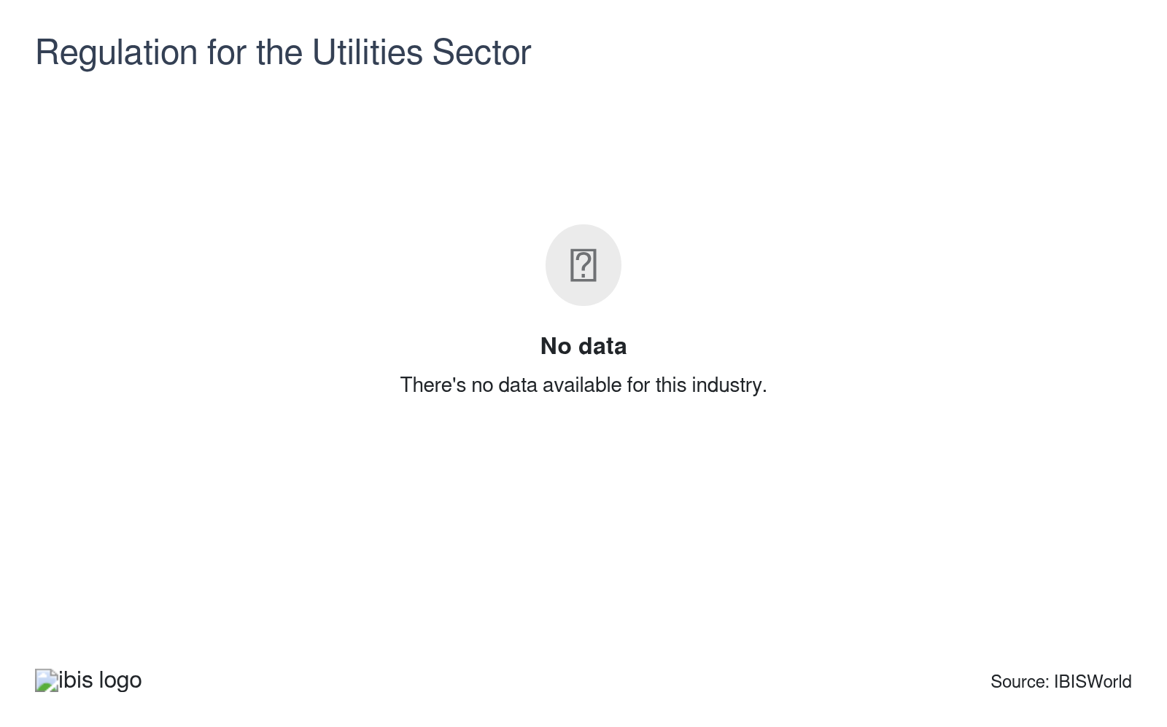
The utility sector experiences significant regulation at the federal, state and local levels. Regulatory agencies oversee the pricing, reliability and safety of sector services. Regulation typically has a negative effect on companies since utility providers need to invest capital to keep up with ever-stringent rules and regulations.

Regulation & Policy
High | Steady

What regulations impact the industry?

Energy Policy Act
The Energy Policy Act (EPAct) sets forth an energy research and development program covering energy efficiency, renewable energy, oil and gas, coal and electricity. The program establishes tax and loan incentives for investing in natural gas and producing electricity from renewable resources. This act also provided wholesale electricity suppliers with access to transmission systems.

Federal Power Act
The Federal Energy Regulatory Commission (FERC) acts as an economic regulator for interstate electricity transmission. The agency oversees reliability standards for bulk power systems and is required to set just and reasonable wholesale electricity prices. The commission's legal authority is derived from the Federal Power Act. FERC regulates wholesale transmission rates and cost recovery, which can influence infrastructure investment and retail prices at the state level.

Environmental Protection Agency
The Environmental Protection Agency (EPA) conducts research, develops, and enforces environmental regulations to protect people and the environment from significant health risks. Utilities must comply with numerous EPA air, water, waste, pollution and land use regulations. Companies regularly monitor and report on their operations, procedures and policies for compliance with existing regulations.

Nuclear Regulatory Commission
The Nuclear Regulatory Commission (NRC) is an independent agency created by the Energy Reorganization Act of 1974. The organization is responsible for ensuring the use of radioactive materials for beneficial civilian purposes while protecting people and the environment. The NRC regulates commercial reactors, the uses of nuclear materials in medical, industrial and academic settings and the transportation, storage and disposal of nuclear waste through licensing, inspection and enforcement.

Affordable Clean Energy Rule
This regulation replaced the 2015 Clean Power Plan, which was ruled to have exceeded the EPA's authority permitted by the Clean Air Act. The new rule promotes energy independence and establishes emissions guidelines for coal-fired power plants.

Public utility commissions
State governments have significant jurisdiction over investor-owned utilities in the major segments of this sector. For example, in-state public utilities commissions (PUCs) have direct jurisdiction over power transmission and distribution, natural gas distribution, water utilities, sewage treatment and steam supply. PUCs have broad authority to establish rates for service, prescribe service standards and review and approve rules and regulations.

Assistance
Moderate | Steady

What assistance is available to this industry?

Infrastructure Investment and Jobs Act
This federal law allocates hundreds of billions of dollars to upgrading the nation's power infrastructure to deliver clean and reliable energy throughout the United States. The law also aims to invest $55.0 billion in expanding access to clean drinking water for residential and nonresidential consumers. It is also set to upgrade power infrastructure across the country by building new resilient large-scale transmission lines, strengthening existing power lines to protect against wildfires and extreme weather, expanding the smart grid and increasing storage, distribution and transmission.

Solar Investment Tax Credit (ITC)
The federal government provides investment tax credits for renewable energy. Solar is included among the renewable energy technologies covered in the tax credit, receiving a 30.0% tax credit until 2020. The Inflation Reduction Act extended the 30.0% tax credit through the end of 2032 and will decline to 26.0% in 2033, 22.0% in 2034 and will end in 2035 unless renewed by Congress.

Energy Policy Act (EPA)
The EPA aims to incentivize the use of renewable energy and reduce greenhouse gases by providing loan guarantees to entities that develop emissions-reducing technologies. Similarly, the act requires companies to increase the amount of biofuel mixed with gasoline.

Solar Energy Industries Association (SEIA)
SEIA focuses on researching industry changes and offers multiple benefits to members and non-members. Member benefits include multiple resources, networking opportunities and discount programs. Non-members can access information regarding the state of the solar power space.

9. Financial Benchmarks
https://my.ibisworld.com/us/en/industry/22/financial-benchmarks
Profit Margin  33.2 %  ↑ Higher than sector | Average Wage  $120k  ↓ Lower than sector | Largest Cost  Purchases  17.2% of Revenue

Key Takeaways
- Regulative rate hikes largely benefit the utilities sector's profitability. These price increases, often approved by public utility commissions, help companies recover costs and significantly boost overall revenue.
- Technological advancements are impacting wages in the utilities sector. While specialized roles still exist, automation has reduced some labor-intensive jobs, leading to falling wages as a revenue share despite high-skill positions.

Cost Structure
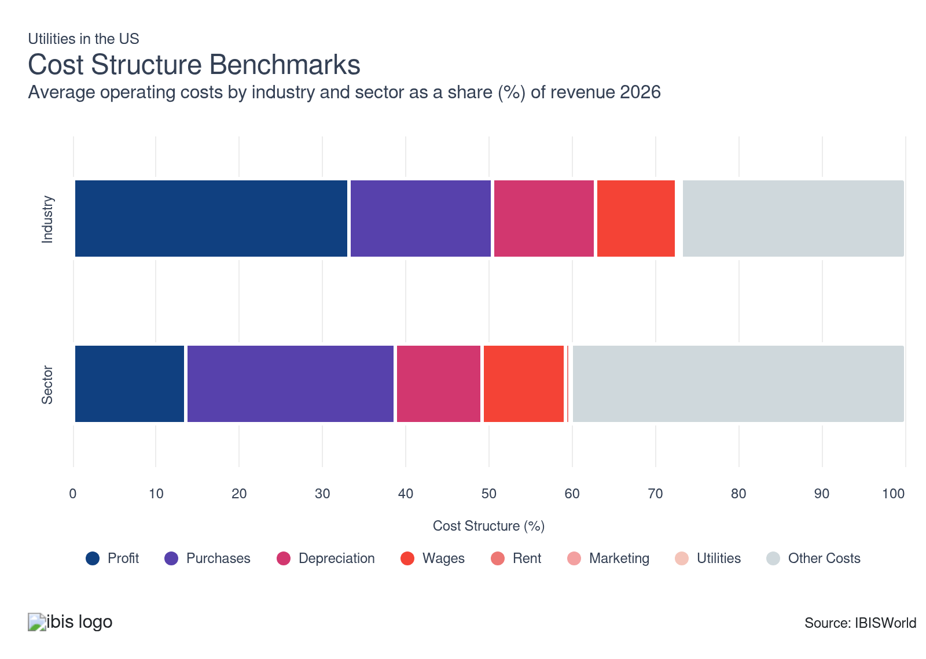
Chart displays current year only in the PDF version of this report. You can view and download chart for all other years associated with this industry on my.ibisworld.com.

What trends impact industry costs?

The utility sector incurs significant depreciation on its property, plant and equipment
- The utilities sector is very capital-intensive, as almost every associated industry requires significant financial investment to purchase, maintain and replace capital assets. This has led depreciation remain steady as a portion of revenue while also exceeding wages.
- Water pipelines, transmission lines, meters, pipeline infrastructure, storage infrastructure, wind turbines, generation plants and solar panels all contribute to a company's depreciation costs in this sector. Nonetheless, companies always enter long-term agreements to keep these costs leveled.

Profit remains strong amid favorable rate hikes
- The utilities sector has high barriers to entry, leading to higher profit among companies. The sector is under stringent oversight by federal, state and local regulators that set prices for utility providers. Regulators ensure prices are high enough for companies to recover expenses and earn sufficient profit.
- Public utilities commissions have permitted electricity producers and distributors to charge higher prices to end users in lieu of higher purchase costs. As a result, profitability remains steady accounting for a third of revenue through 2026.

Wages dip amid technological innovation
- Even though the sector is extremely capital-intensive, it still depends on highly specialized workers, like plant and systems operators, maintenance and repair staff, architects, engineers, information clerks and material moving workers.
- Wages have fallen as a share of revenue, despite most sector employees working in high-skill positions. This is partly because automation technology has cut out some more labor-intensive jobs. While these dips have been gradual, wages as a share of revenue have fallen to below a tenth of revenue for the first time since 2014.

Purchases remain essential for companies in the utility sector
- Purchases remain the highest cost for companies in this sector, accounting for almost a fifth of revenue. In terms of electric power generators, the major costs are the prices of the primary resources used to generate electricity.
- As prices for many electricity-generating commodities dipped, purchases remained stagnant. Consequently, the electric power transmission industry benefited from these lower costs. Stagnant electricity demand, coupled with increased price competition, resulted in more affordable electricity for transmitters. Similarly, natural gas distributors saw declines as the price charged by natural gas pipeline transportation companies fell faster than retail prices.

Marketing is not too important for the utilities sector
- Marketing costs are almost nonexistent for the utility sector. Utilities like electricity, water and gas often operate within markets with little competition. This reduces the need for aggressive marketing, as consumers have fewer options.
- Utilities often rely on long-term contracts and stable customer bases, reducing the need to constantly attract new customers. Many utilities are publicly owned or heavily regulated by public utility commissions, which focus on service reliability and compliance over marketing.

Utility costs can vary based on project and company size
- Utilities, alongside marketing, are the smallest expenses for operators. The majority of utility companies consume the energy produced from the plant for day-to-day operations. Because of this, utility costs remain low.
- Water and sewage treatment facilities typically have higher utility costs than the rest of the sector because they aren't electricity generators and require significant energy consumption for processes like pumping, aeration and filtration.

Rent is typically small but has its purposes
- Rental costs are among the smallest for utility companies, just after marketing and utilities. This cost remains low as companies tend to purchase assets rather than rent them. Most companies own their power plants or facilities.
- Some companies will rent land or office buildings for administrative work. Even so, larger utility companies may headquarter themselves on company-owned property, keeping rent costs low. Companies may also rent equipment for short-term projects, but this is uncommon.
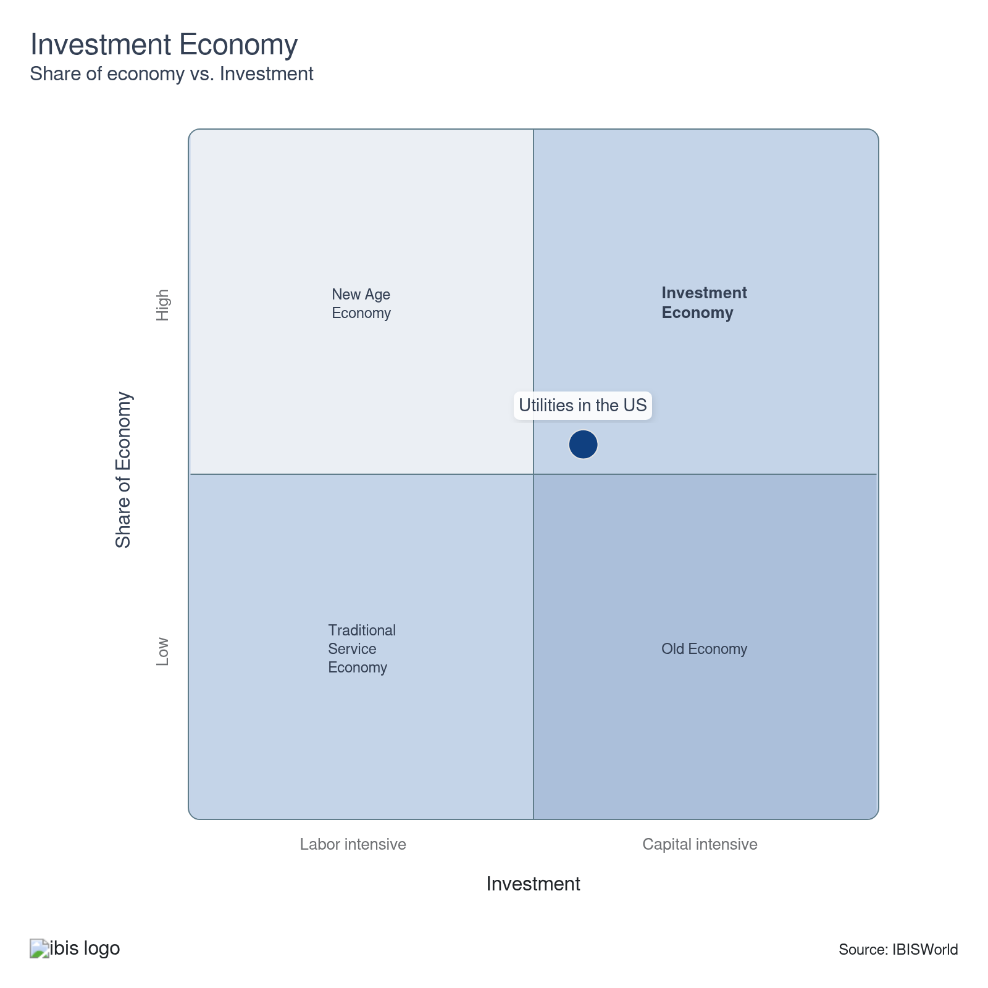

Key Ratios
Year | Revenue per Employee  ($) | Revenue per Enterprise  ($ Million) | Employees per Estab.  (Units) | Employees per Enterprise  (Units) | Average Wage  ($) | Wages/ Revenue  (%) | Estab. per Enterprise  (Units) | IVA/ Revenue  (%)
2005 | 1,221,933 | 20.6 | 12.4 | 16.8 | 105,502 | 8.6 | 1.4 | 41.7
2006 | 1,258,899 | 20.2 | 11.9 | 16.0 | 106,289 | 8.4 | 1.4 | 40.7
2007 | 1,280,408 | 22.0 | 12.5 | 17.2 | 109,903 | 8.6 | 1.4 | 40.8
2008 | 1,308,523 | 24.5 | 12.7 | 18.7 | 112,742 | 8.6 | 1.5 | 40.9
2009 | 1,138,673 | 20.6 | 12.3 | 18.1 | 110,219 | 9.7 | 1.5 | 39.0
2010 | 1,195,634 | 21.4 | 12.2 | 17.9 | 112,128 | 9.4 | 1.5 | 38.3
2011 | 1,177,380 | 21.5 | 12.4 | 18.3 | 114,881 | 9.8 | 1.5 | 38.3
2012 | 1,093,476 | 19.5 | 12.1 | 17.9 | 113,474 | 10.4 | 1.5 | 39.9
2013 | 1,153,695 | 21.2 | 12.4 | 18.4 | 115,123 | 10.0 | 1.5 | 40.0
2014 | 1,208,665 | 22.1 | 12.4 | 18.3 | 115,854 | 9.6 | 1.5 | 41.9
2015 | 1,142,723 | 21.1 | 12.6 | 18.5 | 119,065 | 10.4 | 1.5 | 46.2
2016 | 1,109,592 | 20.6 | 12.6 | 18.6 | 120,269 | 10.8 | 1.5 | 47.3
2017 | 1,103,316 | 20.9 | 12.5 | 19.0 | 120,763 | 10.9 | 1.5 | 45.7
2018 | 1,120,300 | 21.2 | 12.4 | 18.9 | 121,032 | 10.8 | 1.5 | 48.8
2019 | 1,097,106 | 20.3 | 12.2 | 18.5 | 123,227 | 11.2 | 1.5 | 50.7
2020 | 1,065,504 | 19.6 | 12.1 | 18.4 | 125,878 | 11.8 | 1.5 | 54.1
2021 | 1,119,562 | 19.2 | 11.6 | 17.2 | 121,609 | 10.9 | 1.5 | 56.0
2022 | 1,333,375 | 26.2 | 12.8 | 19.6 | 120,185 | 9.0 | 1.5 | 56.3
2023 | 1,182,153 | 23.3 | 12.9 | 19.7 | 120,661 | 10.2 | 1.5 | 54.2
2024 | 1,178,610 | 22.8 | 12.8 | 19.4 | 121,058 | 10.3 | 1.5 | 54.1
2025 | 1,224,609 | 24.2 | 13.0 | 19.8 | 122,015 | 10.0 | 1.5 | 55.1
2026 | 1,233,586 | 24.5 | 13.1 | 19.9 | 119,824 | 9.7 | 1.5 | 55.3
2027 | 1,232,809 | 24.6 | 13.1 | 20.0 | 119,809 | 9.7 | 1.5 | 55.5
2028 | 1,231,682 | 24.7 | 13.2 | 20.0 | 119,787 | 9.7 | 1.5 | 55.6
2029 | 1,234,053 | 24.9 | 13.3 | 20.2 | 119,833 | 9.7 | 1.5 | 55.8
2030 | 1,231,321 | 24.9 | 13.3 | 20.2 | 119,780 | 9.7 | 1.5 | 56.0
2031 | 1,231,759 | 24.9 | 13.3 | 20.2 | 119,789 | 9.7 | 1.5 | 56.1
2032 | 1,231,661 | 25.0 | 13.3 | 20.3 | 119,787 | 9.7 | 1.5 | 56.1
*Figures are inflation adjusted to 2026
*Figures are inflation adjusted to 2026

10. Key Statistics
https://my.ibisworld.com/us/en/industry/22/key-statistics

Industry Data

Values
Year | Revenue  ($ Million) | IVA  ($ Million) | Estab.  (Units) | Enterprises  (Units) | Employment  (Units) | Wages  ($ Million)
2005 | 1,054,184.6 | 439,441.4 | 69,805 | 51,296 | 862,719 | 91,018.7
2006 | 1,064,210.4 | 433,512.9 | 71,151 | 52,704 | 845,350 | 89,851.5
2007 | 1,095,013.7 | 446,931.3 | 68,257 | 49,678 | 855,207 | 93,990.2
2008 | 1,170,021.2 | 478,293.9 | 70,541 | 47,699 | 894,154 | 100,808.7
2009 | 1,031,806.6 | 401,902.7 | 73,822 | 50,021 | 906,148 | 99,874.5
2010 | 1,068,984.3 | 409,944.0 | 73,011 | 49,889 | 894,073 | 100,250.4
2011 | 1,044,187.7 | 399,444.3 | 71,384 | 48,576 | 886,874 | 101,885.2
2012 | 991,551.3 | 395,722.0 | 75,170 | 50,780 | 906,788 | 102,896.8
2013 | 1,025,622.1 | 410,252.5 | 71,720 | 48,424 | 888,989 | 102,342.8
2014 | 1,076,783.8 | 450,769.0 | 71,896 | 48,714 | 890,887 | 103,212.7
2015 | 1,021,721.0 | 472,409.3 | 71,042 | 48,310 | 894,111 | 106,457.6
2016 | 994,898.0 | 471,048.6 | 71,219 | 48,290 | 896,634 | 107,837.0
2017 | 1,006,710.5 | 459,638.9 | 73,271 | 48,129 | 912,441 | 110,189.4
2018 | 1,039,116.6 | 507,449.6 | 74,675 | 49,121 | 927,534 | 112,261.2
2019 | 1,014,248.4 | 514,170.3 | 75,881 | 50,062 | 924,476 | 113,920.2
2020 | 979,534.6 | 529,866.7 | 75,972 | 50,043 | 919,316 | 115,721.6
2021 | 1,041,161.6 | 582,808.5 | 80,224 | 54,154 | 929,972 | 113,093.2
2022 | 1,186,547.4 | 668,602.4 | 69,501 | 45,330 | 889,883 | 106,950.4
2023 | 1,083,050.7 | 587,254.6 | 70,837 | 46,560 | 916,168 | 110,545.8
2024 | 1,096,649.2 | 593,613.1 | 72,782 | 48,049 | 930,460 | 112,639.2
2025 | 1,176,732.5 | 648,871.9 | 73,754 | 48,540 | 960,905 | 117,245.0
2026 | 1,200,245.8 | 663,564.9 | 74,359 | 48,898 | 972,973 | 116,585.6
2027 | 1,203,057.2 | 668,129.6 | 74,376 | 48,905 | 975,867 | 116,917.7
2028 | 1,205,662.7 | 670,817.3 | 74,382 | 48,906 | 978,875 | 117,256.6
2029 | 1,214,493.6 | 677,664.1 | 74,184 | 48,729 | 984,150 | 117,933.9
2030 | 1,221,356.8 | 683,736.2 | 74,771 | 49,126 | 991,908 | 118,810.9
2031 | 1,235,047.7 | 693,326.9 | 75,456 | 49,570 | 1,002,670 | 120,108.5
2032 | 1,245,459.5 | 699,165.9 | 75,945 | 49,881 | 1,011,203 | 121,128.8

*Figures are inflation adjusted to 2026

Annual Change
Year | Revenue  % | IVA  % | Estab.  % | Enterprises  % | Employment  % | Wages  %
2005 | N/A | N/A | N/A | N/A | N/A | N/A
2006 | 1.0 | -1.3 | 1.9 | 2.7 | -2.0 | -1.3
2007 | 2.9 | 3.1 | -4.1 | -5.7 | 1.2 | 4.6
2008 | 6.8 | 7.0 | 3.3 | -4.0 | 4.6 | 7.3
2009 | -11.8 | -16.0 | 4.7 | 4.9 | 1.3 | -0.9
2010 | 3.6 | 2.0 | -1.1 | -0.3 | -1.3 | 0.4
2011 | -2.3 | -2.6 | -2.2 | -2.6 | -0.8 | 1.6
2012 | -5.0 | -0.9 | 5.3 | 4.5 | 2.2 | 1.0
2013 | 3.4 | 3.7 | -4.6 | -4.6 | -2.0 | -0.5
2014 | 5.0 | 9.9 | 0.2 | 0.6 | 0.2 | 0.8
2015 | -5.1 | 4.8 | -1.2 | -0.8 | 0.4 | 3.1
2016 | -2.6 | -0.3 | 0.2 | 0.0 | 0.3 | 1.3
2017 | 1.2 | -2.4 | 2.9 | -0.3 | 1.8 | 2.2
2018 | 3.2 | 10.4 | 1.9 | 2.1 | 1.7 | 1.9
2019 | -2.4 | 1.3 | 1.6 | 1.9 | -0.3 | 1.5
2020 | -3.4 | 3.1 | 0.1 | 0.0 | -0.6 | 1.6
2021 | 6.3 | 10.0 | 5.6 | 8.2 | 1.2 | -2.3
2022 | 14.0 | 14.7 | -13.4 | -16.3 | -4.3 | -5.4
2023 | -8.7 | -12.2 | 1.9 | 2.7 | 3.0 | 3.4
2024 | 1.3 | 1.1 | 2.7 | 3.2 | 1.6 | 1.9
2025 | 7.3 | 9.3 | 1.3 | 1.0 | 3.3 | 4.1
2026 | 2.0 | 2.3 | 0.8 | 0.7 | 1.3 | -0.6
2027 | 0.2 | 0.7 | 0.0 | 0.0 | 0.3 | 0.3
2028 | 0.2 | 0.4 | 0.0 | 0.0 | 0.3 | 0.3
2029 | 0.7 | 1.0 | -0.3 | -0.4 | 0.5 | 0.6
2030 | 0.6 | 0.9 | 0.8 | 0.8 | 0.8 | 0.7
2031 | 1.1 | 1.4 | 0.9 | 0.9 | 1.1 | 1.1
2032 | 0.8 | 0.8 | 0.6 | 0.6 | 0.9 | 0.8

*Figures are inflation adjusted to 2026

DISCLAIMER
This product has been supplied by IBISWorld Inc. (‘IBISWorld’) solely for use by its authorized licenses strictly in accordance with their license agreements with IBISWorld. IBISWorld makes no representation to any other person with regard to the completeness or accuracy of the data or information contained herein, and it accepts no responsibility and disclaims all liability (save for liability which cannot be lawfully disclaimed) for loss or damage whatsoever suffered or incurred by any other person resulting from the use of, or reliance upon, the data or information contained herein. Copyright in this publication is owned by IBISWorld Inc. The publication is sold on the basis that the purchaser agrees not to copy the material contained within it for other than the purchasers own purposes. In the event that the purchaser uses or quotes from the material in this publication – in papers, reports, or opinions prepared for any other person – it is agreed that it will be sourced to: IBISWorld Inc.

